

COS209 Final Project Assignment

Thant nyi nyi thaw

HDIT | BUC | 24.9.2023

Contents

1.Project Overview 3

1.1 Background 4

1.2 Project Initiation 4

1.3 Scope of the System 4

1.4 Project Constraints 5

1.4.1 Design 5

1.4.2 Payment method 5

1.5 Project Risks 5

1.5.1 Stocks 5

1.5.2 Price 5

1.6 Schdule and Budget 6

1.6.1 Planning and Designing (15 days) 6

1.6.2 Development (50 days) 6

1.6.3 Launching and Maintenance (15 days) 6

2 Requirements Definition 7

2.1 Target Audience 7

2.2 Hardware Requirements 7

2.3 Software Requirements 7

2.4 Funtions and Features Requirements 8

2.5 Non-functional Requirements 9

2.6 Project Members 9

3. Work BREAKDOWN STRUCTURE 11

4. Gantt Chart 12

4.1. Planning and Designing 12

4.2. Development 12

4.3. Launching and Maintenece 13

5 Budget Summary 13

Section B 14

1 Use Case Diagram 14

2.2 Activity Diagram 15

2.3 Sequence Diagram 16

2.4 State Chart Diagram 16

3 Process Description 17

Section C: Database Design 1 Database 18

2.Program hierachical design 21

3 Mini specifications 22

4. Web Design for Admin 22

4.1 Admin Login (default names are written here for the convinence during test run.) 23

4.2 Admin Home Page 23

4.3 Admin Update Profile 24

4.4 See Orders () 25

4.5 Products 25

5. Web Design for Users 31

6 Security System 43

Section D: Ststem Testing & Implementation 44

1. Test plan, Test data, Test result 44

2. System Implementation 48

2.1 Implementation Plan 48

Section E : Critical Apprisal 75

System Limitation 75

Recommended changes 75

Critical Reflection of the Project Experience 76

References 77

# 1.Project Overview

First of all, I would like to explain in brief about the website, shopping spree, and its overall specifications.

## 1.1 Background

The company is a new online retailer that specializes in electronic items. The company's mission is to be the leading online retailer of electronic items by providing customers with the best possible selection, prices, and customer service.

## 1.2 Project Initiation

The project to create a website for the company was initiated in response to the growing demand for online shopping for electronic items. The company's founders recognized that there was a need for a website that would provide customers with a comprehensive selection of electronic items from a variety of reputable retailers. The website would also offer competitive prices and excellent customer service.

## 1.3 Scope of the System

The scope of the system includes the following:

* A database of electronic items from a variety of retailers
* A search engine that allows customers to find specific items
* A shopping cart that allows customers to purchase items
* A checkout process that is secure and easy to use
* A customer support system that is responsive and helpful

## 1.4 Project Constraints

### 1.4.1 Design

Despite our great effort in the greater of efficiency in the application, there are also some constraints about the website in actually applying it practically. Since the website emphasize on smoothness of the functions in the website, there are lack of stats in color theory. Even though, the company wants to display a simple and modest version of type, some users may think it lack more fancy design.

### 1.4.2 Payment method

Another constraint in our interface may happens in the payment interface. In final purchase step of our website, users can chose their preferred payment method. However, there are no specific identifications and validations to it. For instance, when a user choose credit card payment, there will be no further asking for the credit or debit card information’s.

## 1.5 Project Risks

### 1.5.1 Stocks

Since the website is retail online shopping style, the items will be ordered as the users demand instead of keeping them in the warehouse as in-stock. This can leads to traffic of items where there is a mass buying from users. For example, when there is newly released or discounted items in the store and mass buying occurred, some of the users’ order might got canceled.

### 1.5.2 Price

Nowadays, due to inflation around the world, the price of electronic can be varied each week or even days sometimes. Therefore, if the price were to raise after customers order is already is completed, the company may lose a few assets and profits over that item.

## 1.6 Schdule and Budget

As for the time management plan, we have estimated that the project should take from 2 to 3 months with approximate expanse of $100,000 depending on the Triple Constraint. Approximately, there will be 3 phases for the project.

### 1.6.1 Planning and Designing (15 days)

First of all, meeting with clients and contracting about the website overview. After that, defining project goals and objectives will take 3 days. Secondly, conducting a research on market should take 5 days. Developing a website frame should take 4 days. Then, drafty planning a schedule and budget plan should take 3 days with a total of 15 days.

The estimate budget for this phase is around $10,000 for project manager, system analysis, web designer and web developers.

### 1.6.2 Development (50 days)

There will be writing a back-end and front-end of the website and its interfaces which should take around 40 days. After that, testing and debugging the website before it launch should take 10 days.

The estimate budget for this phase is around $75,000 including the fees for web developer, back-end developer, front-end developer and quality assurance manager.

### 1.6.3 Launching and Maintenance (15 days)

Starting with launching the website as a beta for 7 days while monitoring the website’s traffic and performance. Utilizing these data, improving the website for better quality and efficiency, the company will take around 8 days to officially launch the website.

The estimate budget for this phase is around $15,000, especially for domain name, hosting services and marketing team.

# 2 Requirements Definition

In executing a project of the website to completion, there are variety of necessary and requirements.

## 2.1 Target Audience

To get a better and faster fame, it is important to knows which audience to target. Since this is electronic goods, our target audience range from teenagers to middle-aged customers.

## 2.2 Hardware Requirements

In order to run with high efficiency, the website need to be hosted on a secure and reliable server. The server should have high processing power and memory. It is also a necessary to have a faster bandwidth. Furthermore, we will also need a fully functional database.

## 2.3 Software Requirements

First of all, the website should be developed on a dependable and flexible platform for multi-users. The coding need to be consistent enough to respond to users quick and smooth. The data and information of the users need to be secured. In addition, the validations and test runs are also needed so that the website can withstands up to a certain maximum numbers of users. In this project we use PHP,PDO,SQL,JS,CSS and HTML coding to fulfill the maximum potential of the website.

## 2.4 Funtions and Features Requirements

* User registration and login: Users must be able to register for an account and log in to the website.
* Product search: Users must be able to search for products by keyword, category, or brand.
* Product listing: Products must be listed in a way that is easy to browse and search.
* Product details: Each product must have a detailed description, including images, videos, and specifications.
* Shopping cart: Users must be able to add products to a shopping cart and checkout.
* Payment processing: The website must support multiple payment methods, such as credit cards, debit cards, and PayPal.
* Order tracking: Users must be able to track the status of their orders.
* Wishlist: Users should be able to create a Wishlist of products that they are interested in.

These are additional requirements that the developers suggest for the better of the application that can be added.

* Reviews and ratings: Users should be able to leave reviews and ratings for products.
* Personalization: The website should be personalized for each user, based on their interests and preferences.
* Social media integration: The website should be integrated with social media platforms, so that users can share products with their friends.

## 2.5 Non-functional Requirements

* Security: The website must be secure and protect sensitive data, such as passwords.
* Scalability: The website must be able to scale to handle increased traffic and demand.
* Availability: The website must be available 24/7.
* Usability: The website must be easy to use and navigate.
* Maintainability: The website must be easy to maintain and update.
* Testability: The website must be easy to test.
* Performance: The website must be able to handle a large number of users and transactions without any performance issues.

## 2.6 Project Members

This project require at least 8 people to complete the project.

* Project manager: The project manager is responsible for overseeing the project and ensuring that it is completed on time and within budget.
* Business analyst: The business analyst is responsible for gathering and understanding the requirements of the business.
* UX/UI designer: The UX/UI designer is responsible for designing the website in a way that is user-friendly and visually appealing.
* Web developer: The web developer is responsible for developing the website using the required technologies.
* QA engineer: The QA engineer is responsible for testing the website to ensure that it meets all of the requirements.
* Content writer: The content writer is responsible for writing the content for the website, such as product descriptions and blog posts.
* Marketing manager: The marketing manager is responsible for promoting the website and driving traffic to it.
* Legal and Consultants: The legal and consultants are responsible for the communication between clients and company. They are also accountable for contracting.

# 3. Work BREAKDOWN STRUCTURE

# 4. Gantt Chart

## 4.1. Planning and Designing

## 4.2. Development

## 4.3. Launching and Maintenece

# 5 Budget Summary

|  |  |
| --- | --- |
| Course | Approximate expense |
| Hiring Teams | $2000-$4000 monthly |
| Hardware expense | $5000 |
| License, servers and database | $20000 |
| General Cost | $1000-$2000 monthly |

# Section B

# 1 Use Case Diagram

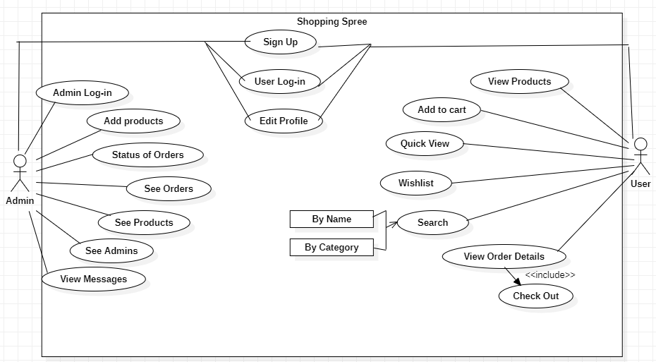

# 2.1 Class Diagram

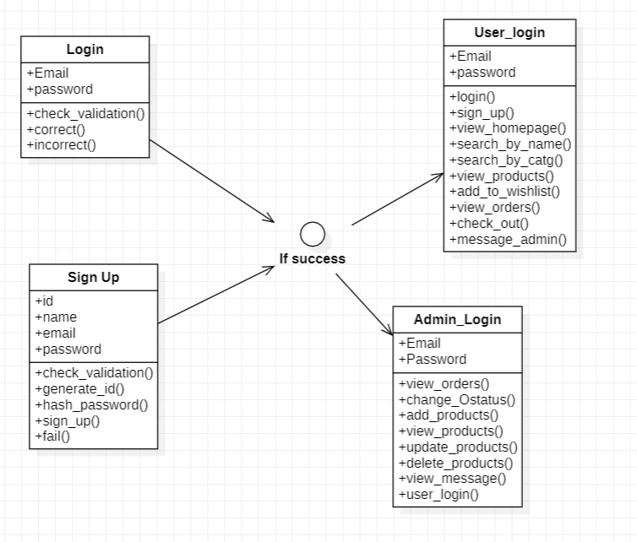

# 2.2 Activity Diagram

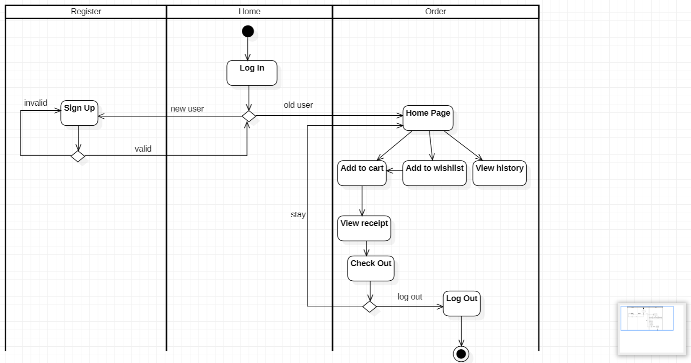

# 2.3 Sequence Diagram

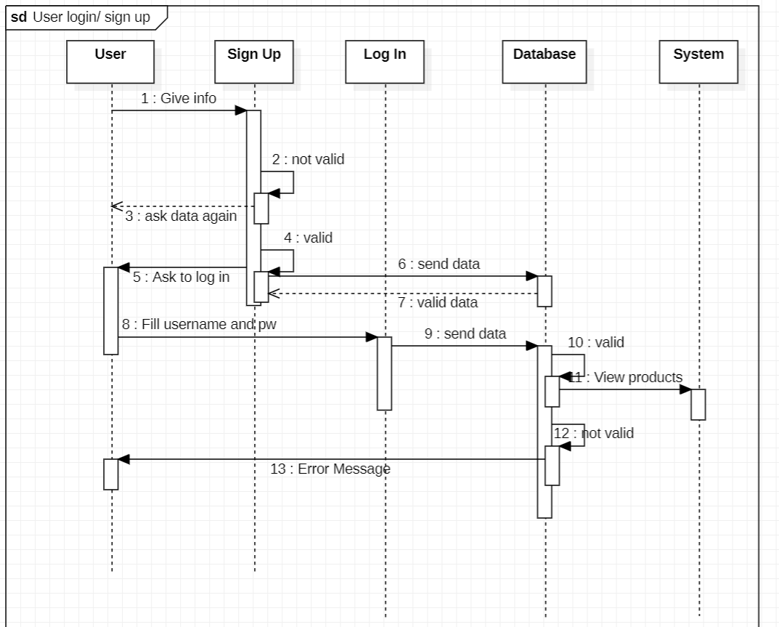

# 2.4 State Chart Diagram

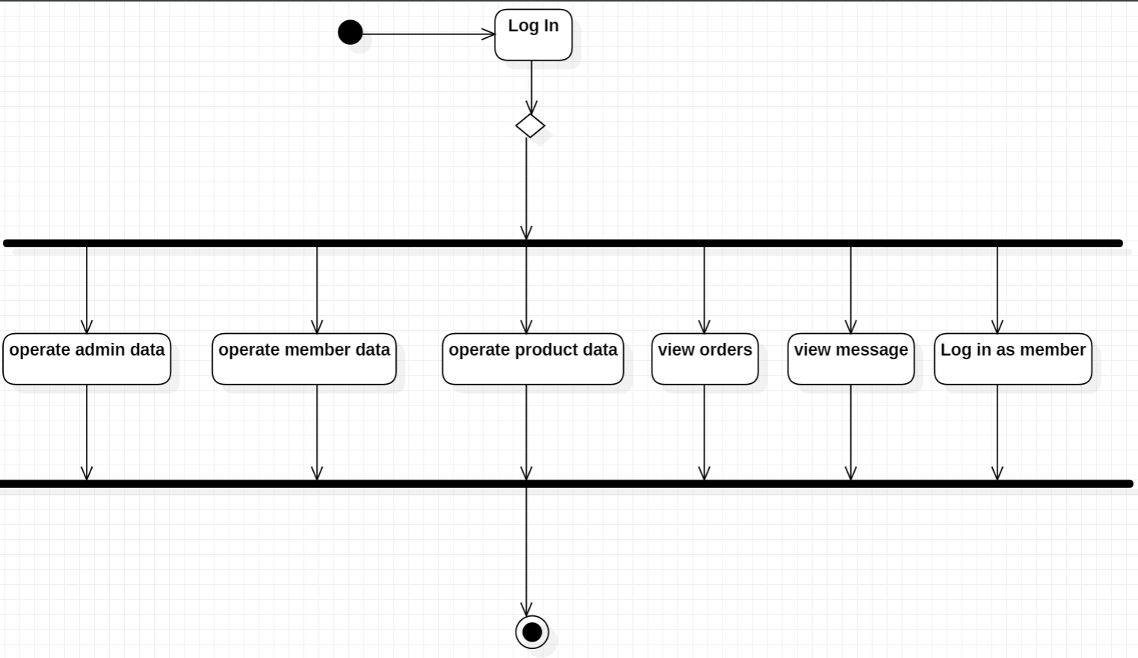

# 3 Process Description

|  |  |  |
| --- | --- | --- |
| **Phase** | **Activity** | **Description** |
| **Initiation** | Define the project's goals, scope, budget, and timeline. | The goal of this phase is to define the project and get approval from all stakeholders. The scope should define the products or services that will be delivered, as well as the features and functionality that will be included. The budget should estimate the costs of the project, and the timeline should estimate how long the project will take to complete. |
| **Planning** | Develop a detailed project plan, including tasks, resources, risks, and schedule. | The goal of this phase is to develop a plan for how the project will be executed. The project plan should include a list of all the tasks that need to be completed, as well as the resources that will be needed for each task. The project plan should also identify any risks that could impact the project, and develop mitigation strategies. Finally, the project plan should create a schedule for the project, with estimated start and end dates for each task. |
| **Execution** | Complete the tasks identified in the project plan, monitor progress, and make adjustments as needed. | The goal of this phase is to execute the project according to the plan. The project manager will need to monitor the project's progress and make adjustments as needed. This may involve adjusting the schedule, budget, or scope of the project. |
| **Closure** | Deliver the project's products or services to the stakeholders, finalize the budget and timeline, and review the project to identify lessons learned. | The goal of this phase is to close out the project and ensure that all stakeholders are satisfied. The project manager will need to deliver the project's products or services to the stakeholders, finalize the budget and timeline, and review the project to identify lessons learned. |

# Section C: Database Design 1 Database

**Admin**

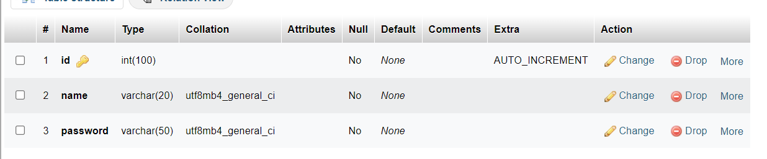

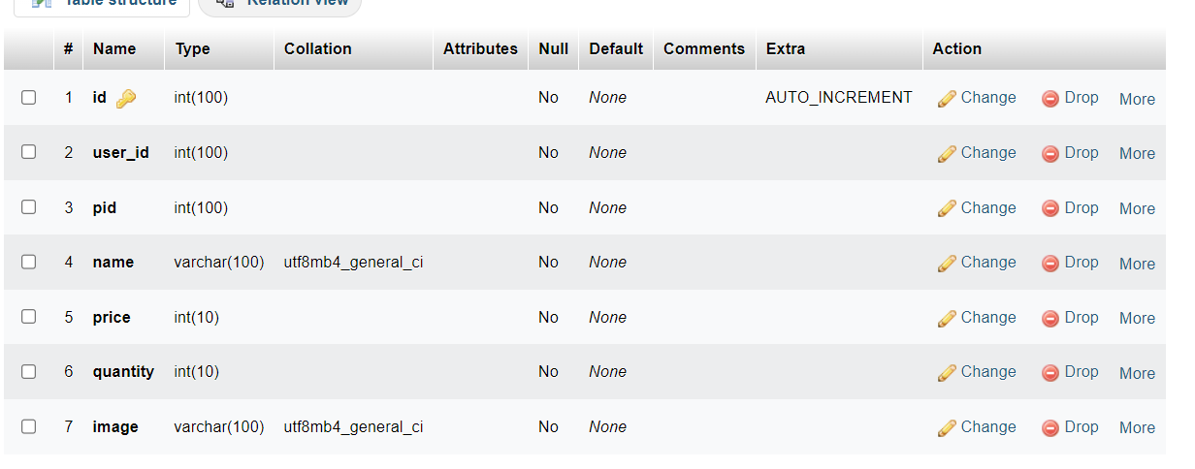 **Cart**

**Message**

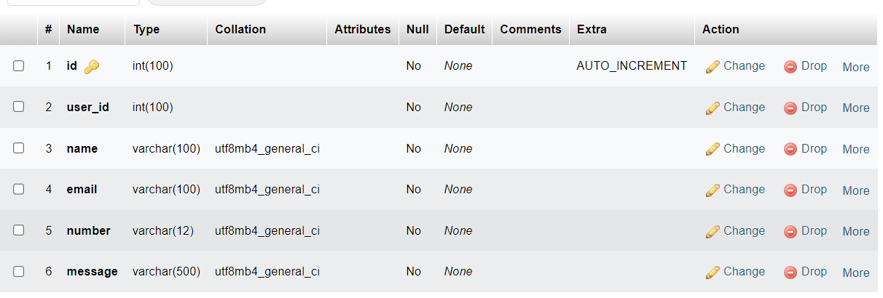

**Orders**

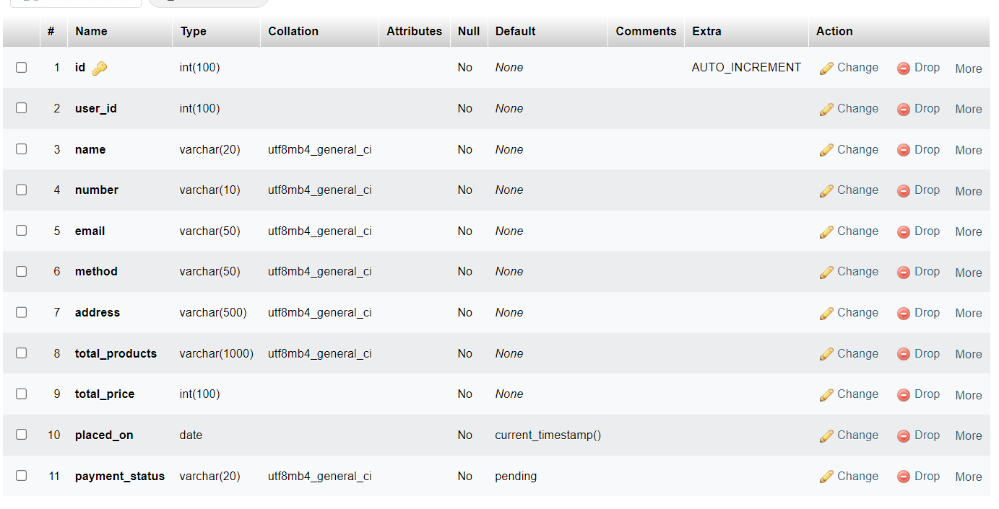

**Products**

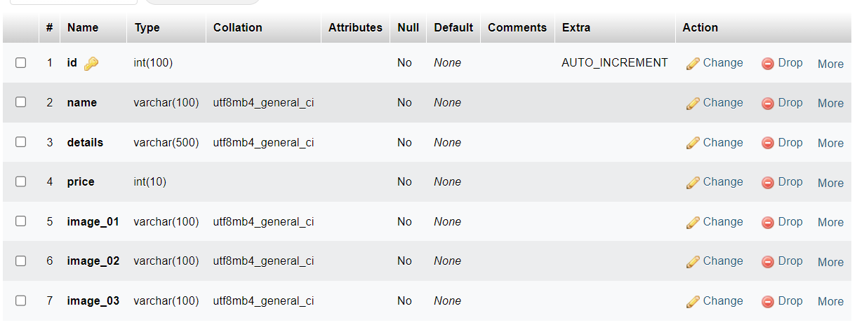

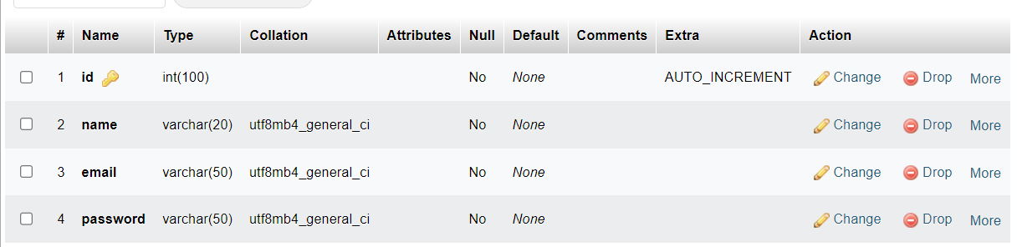**Users**

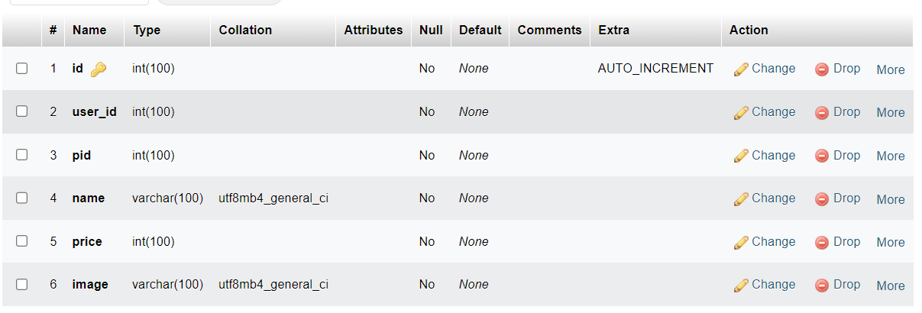**Wishlist**

2.Program hierachical design

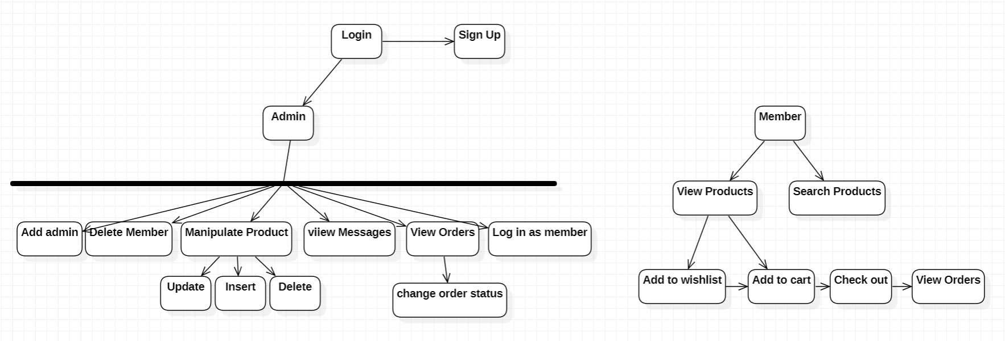

3 Mini specifications

Admin – if its logged in from admin page, the system will show the functions that the admin can do such as add admins, Delete member, manipulate the data(insert,update,delete), view messages from customers, view orders and change the status(pending,complete). They can log in as user too. Users can not log in as admin since login in pages are isolated.

Users – Users can logged in with their email and password. If logged in is valid, they can view products in homepage, or they can search by either name or category. Users can add the product to Wishlist and to cart. Via add to cart, users can proceed to check-out which leads to orders. Since it is retail page, for the benefit of company, canceling the order is not available. Users can pay by various methods such as cash on delivery, PayPal or credit card. In addition, users can also send messages to admin as a review.

Sign up – Admins and users can sign up in this page and the password is hashed so that it can’t be view in database for privacy.

4. Web Design for Admin

### 4.1 Admin Login (default names are written here for the convenience during test run.)

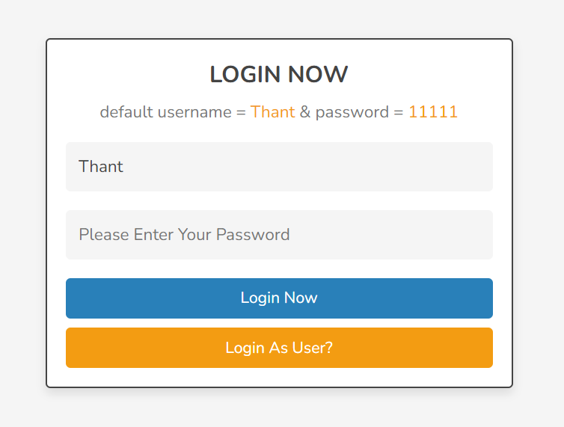

### 4.2 Admin Home Page

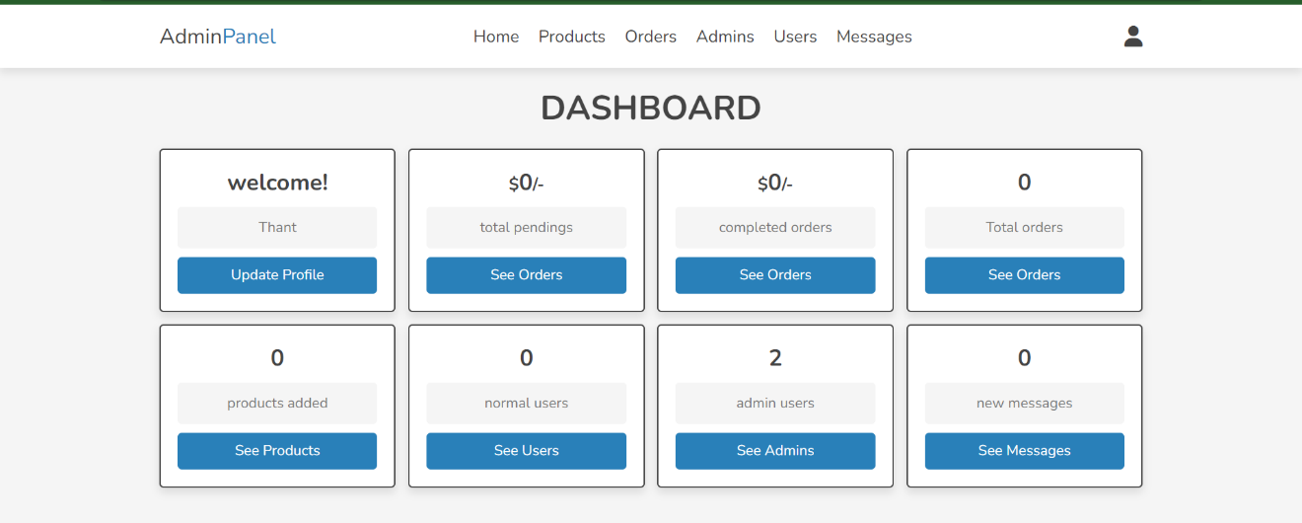

### 4.3 Admin Update Profile

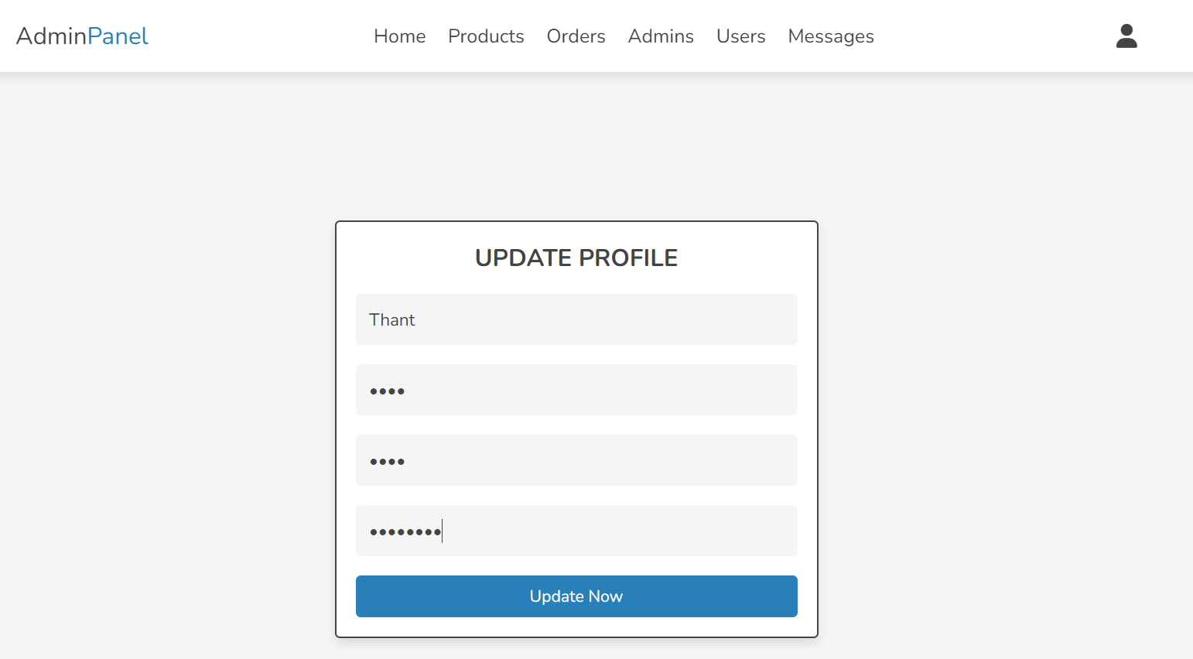

### 4.4 See Orders ()

### 4.5 Products

#### 4.5.1Add Products

#### 4.5.2 View Products

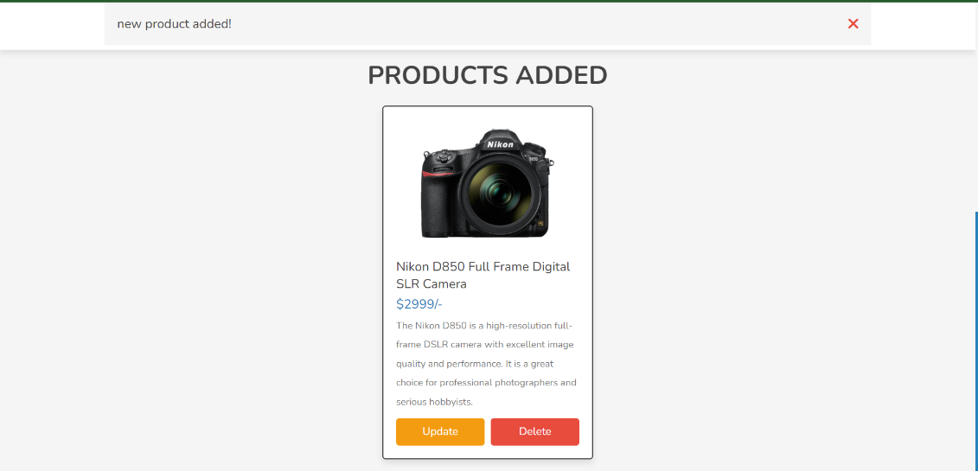

#### 4.5.3 Update Products

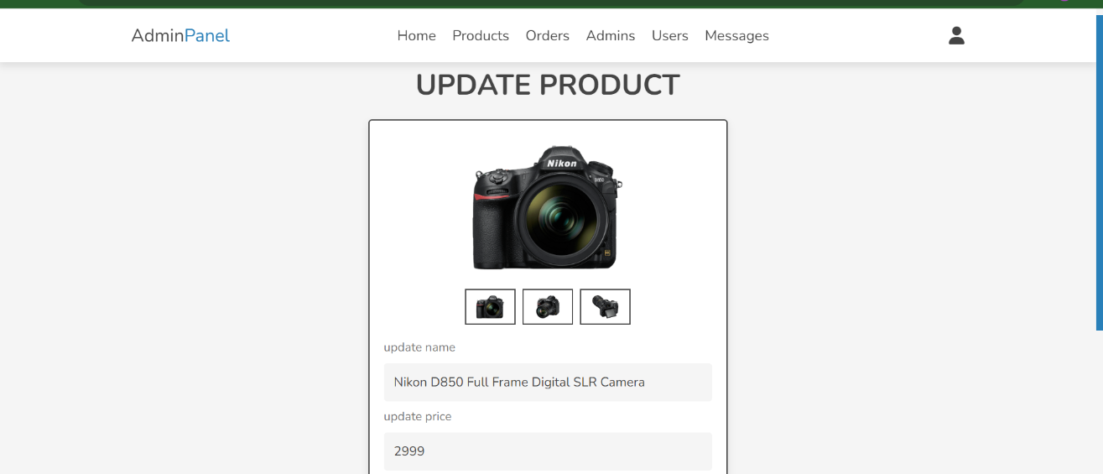

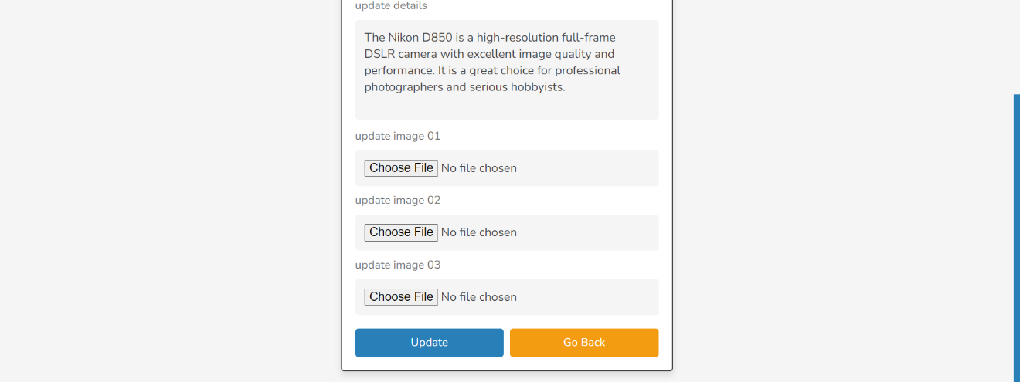Sadaf

Sadaf

#### 4.5.4 Delete Product

#### 4.6 See and Delete Users

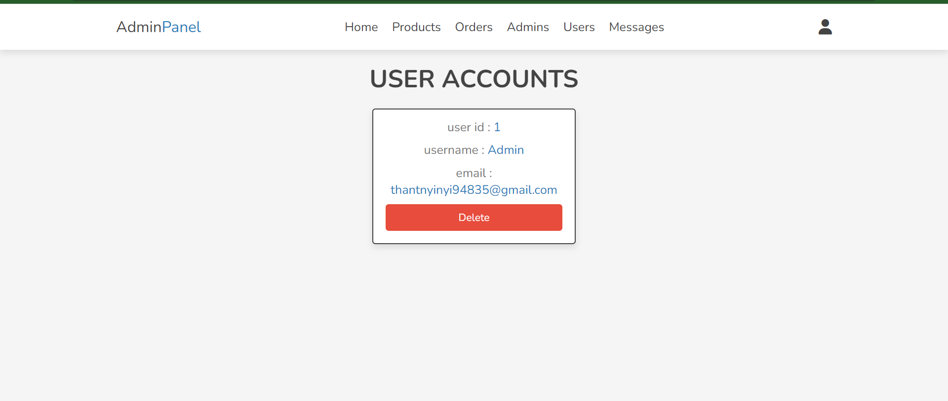

#### 4.7 View Admins

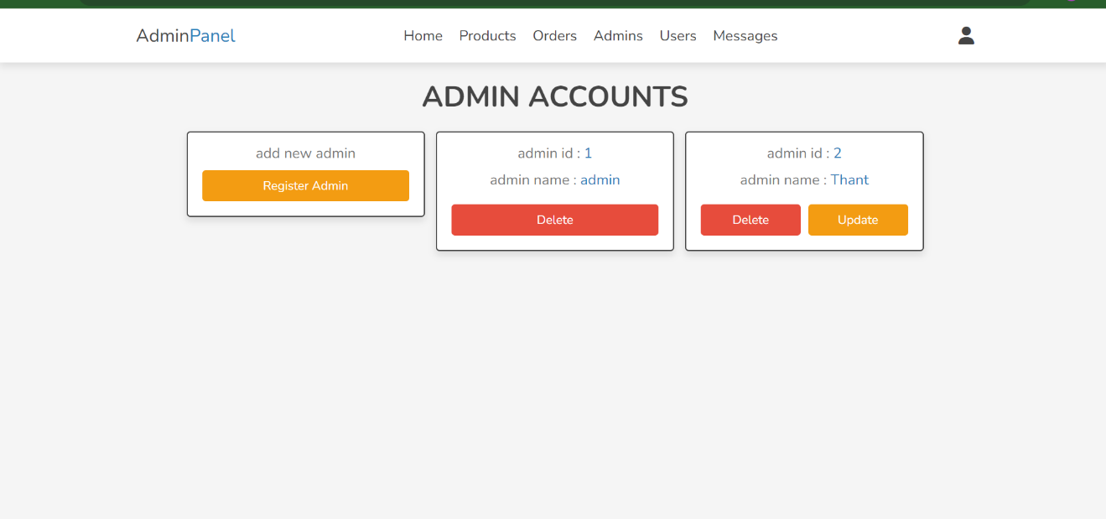

#### 4.8 Register Admin

#### 4.9 Delete Admin

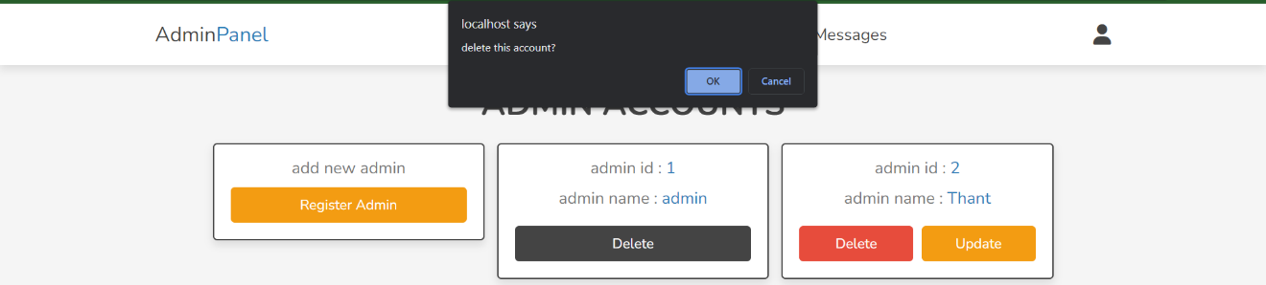

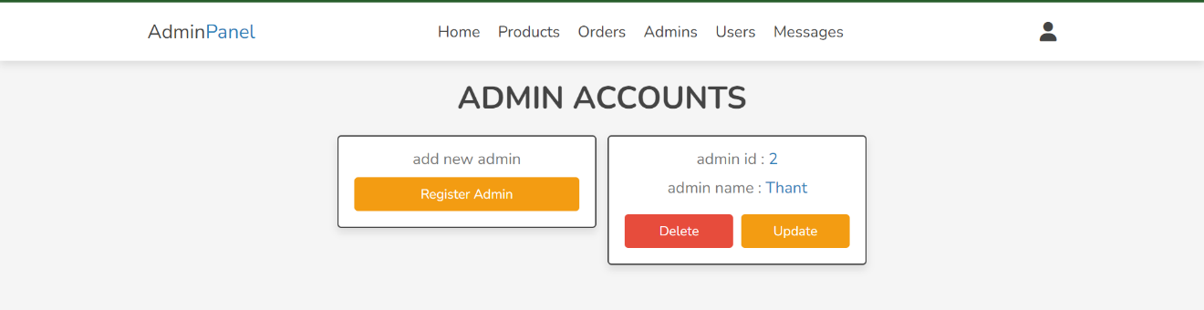

#### 4.10 View Messages

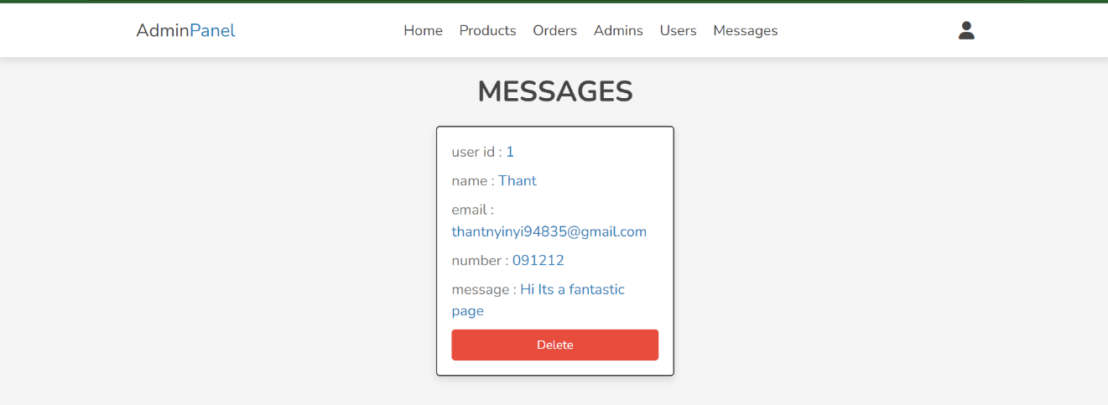

### 5. Web Design for Users

#### 5.1 Login

#### 5.2 Sign Up

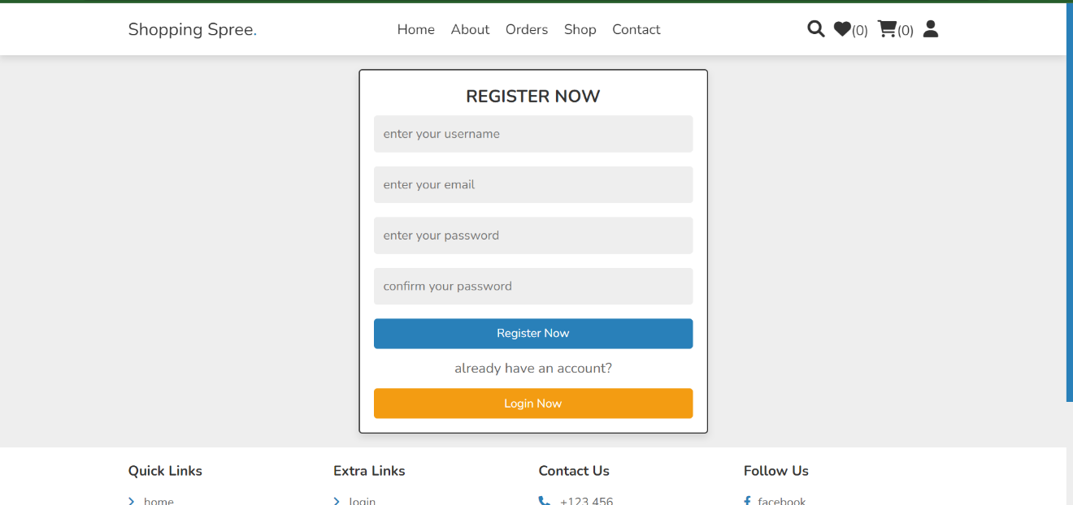

#### 5.3 Index page/home page



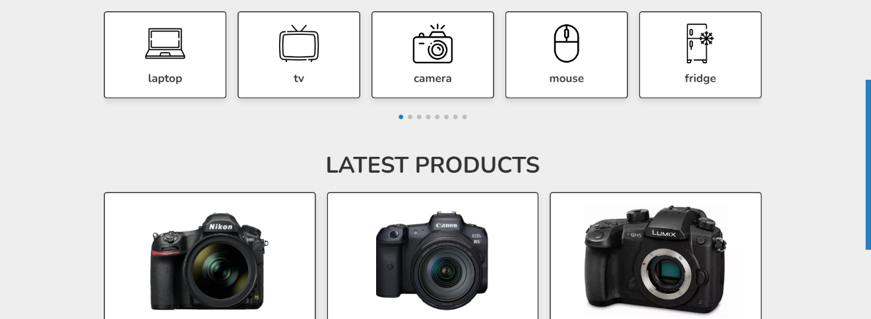

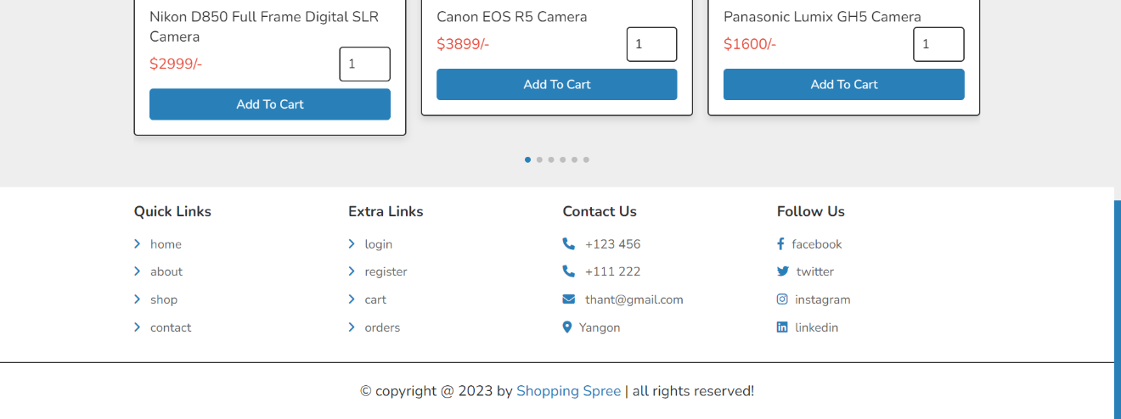 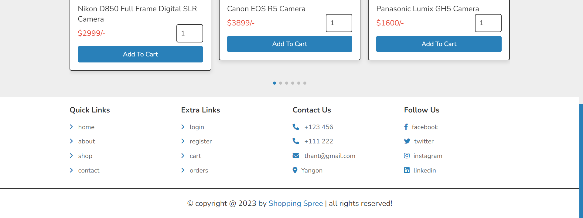

#### 5.4 About Us

#### 5.5 Orders

#### 5.6 Shopping

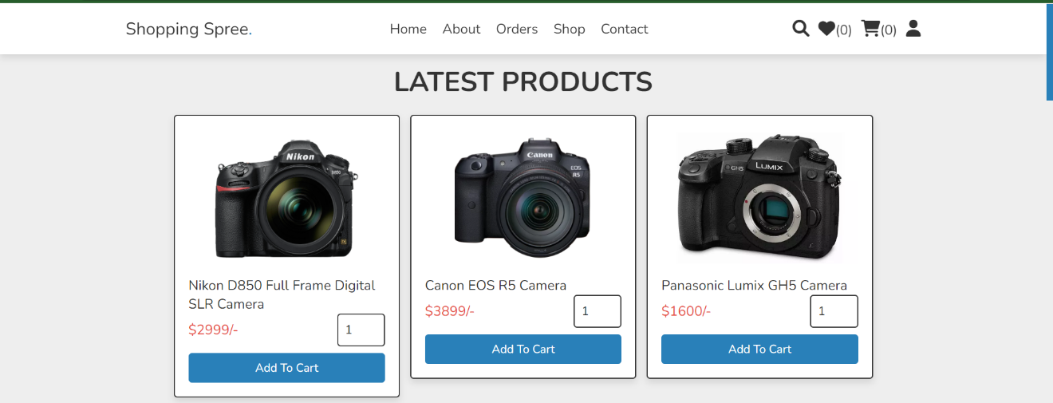

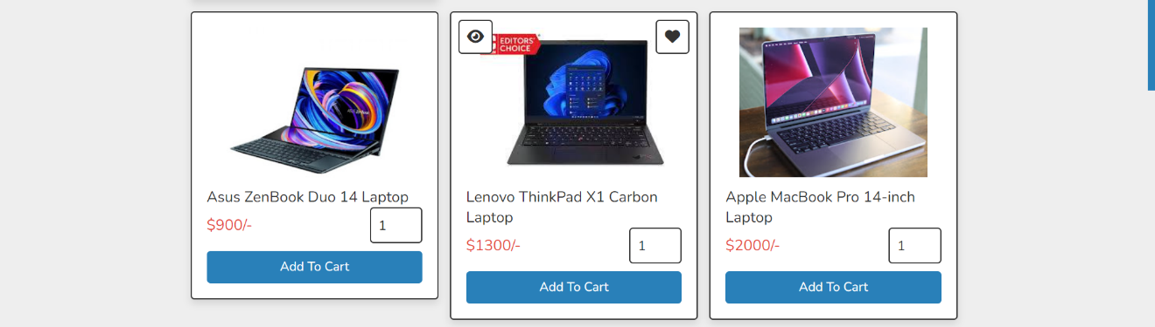

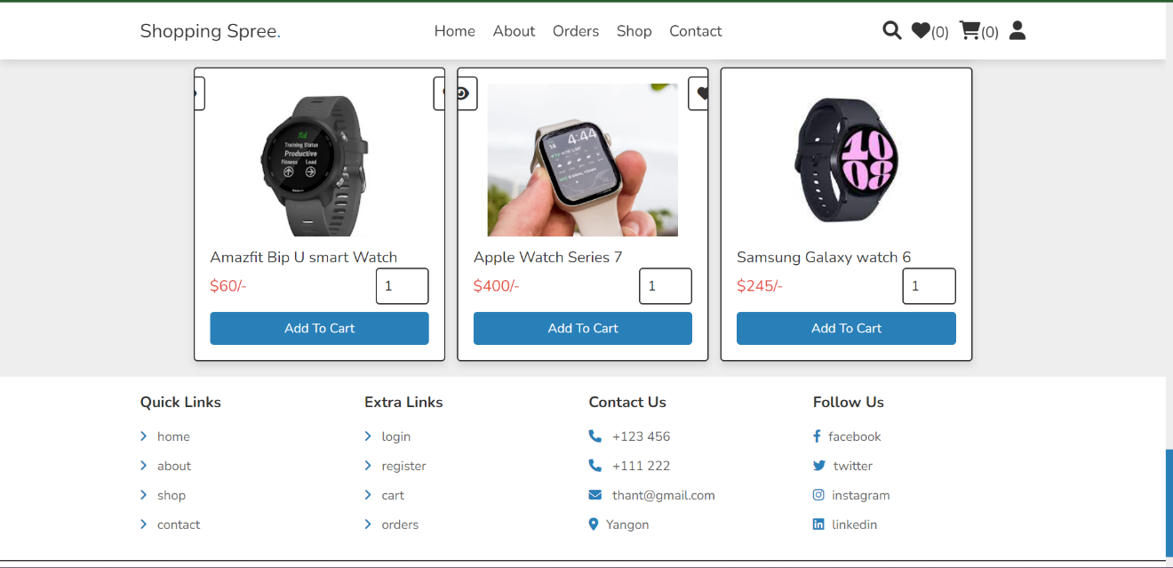

#### 5.6.1 View Detail

#### 5.6.2 Add to Wishlist

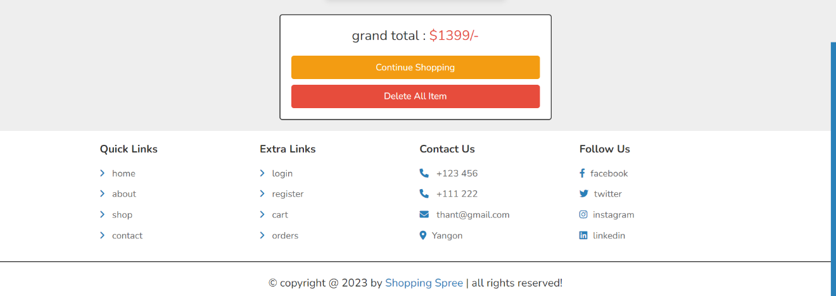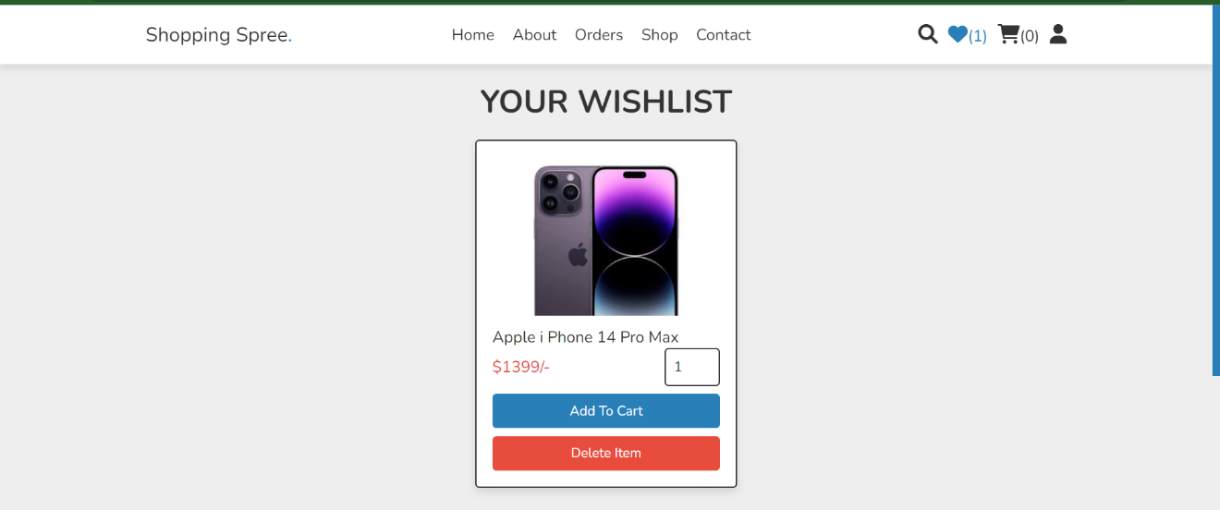

#### 5.6.3 Add to cart

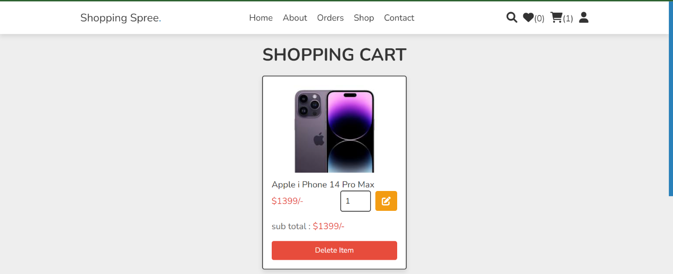

a

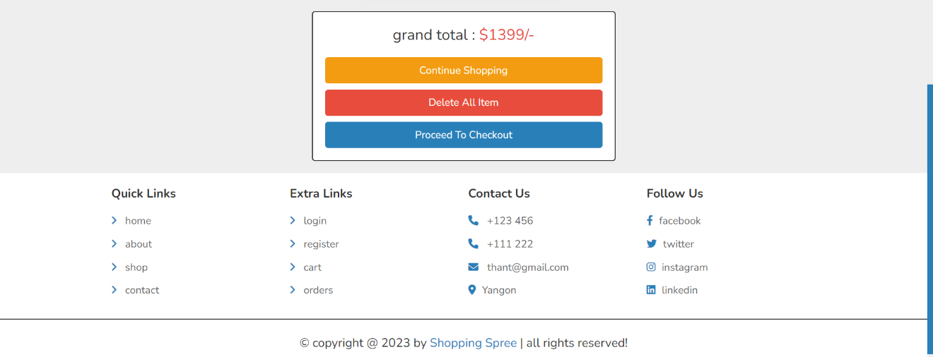

#### 5.6.4 Checkout

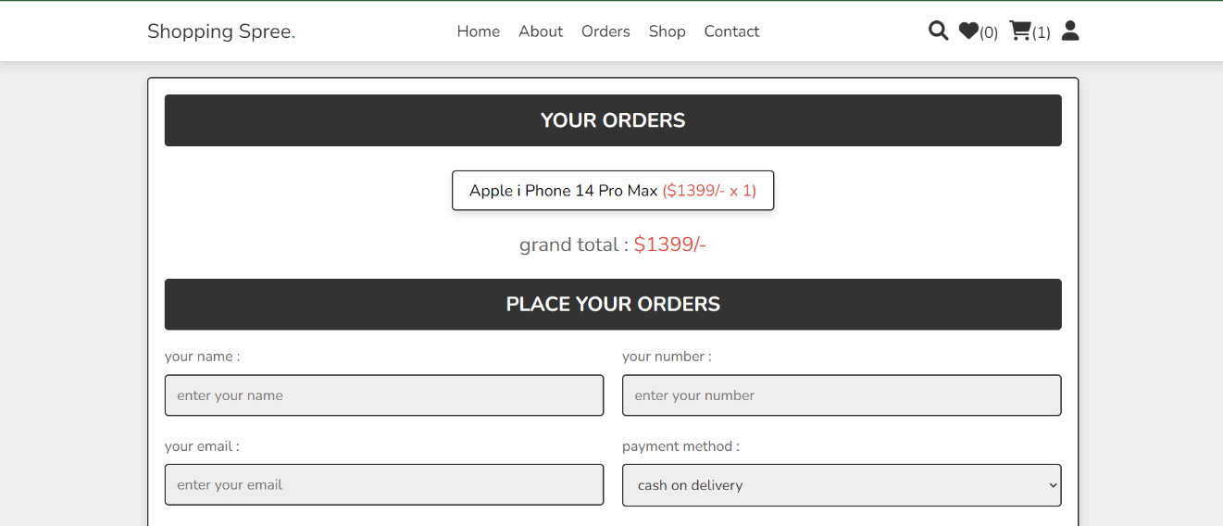

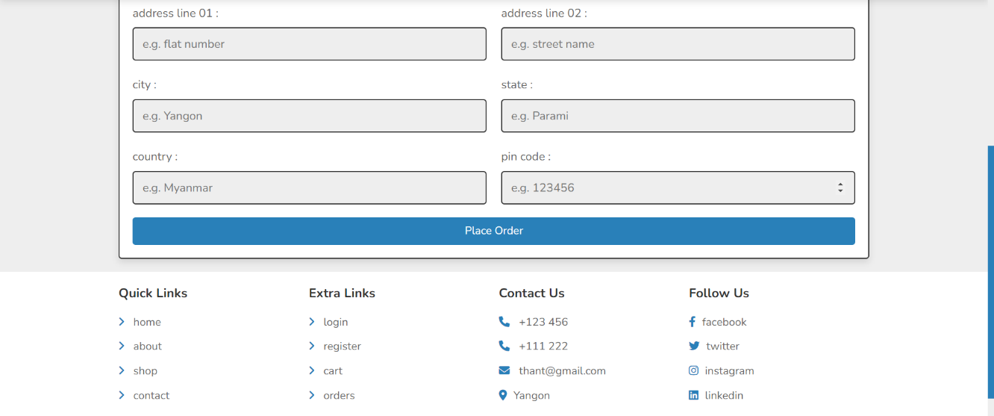

#### 5.7 Send Message

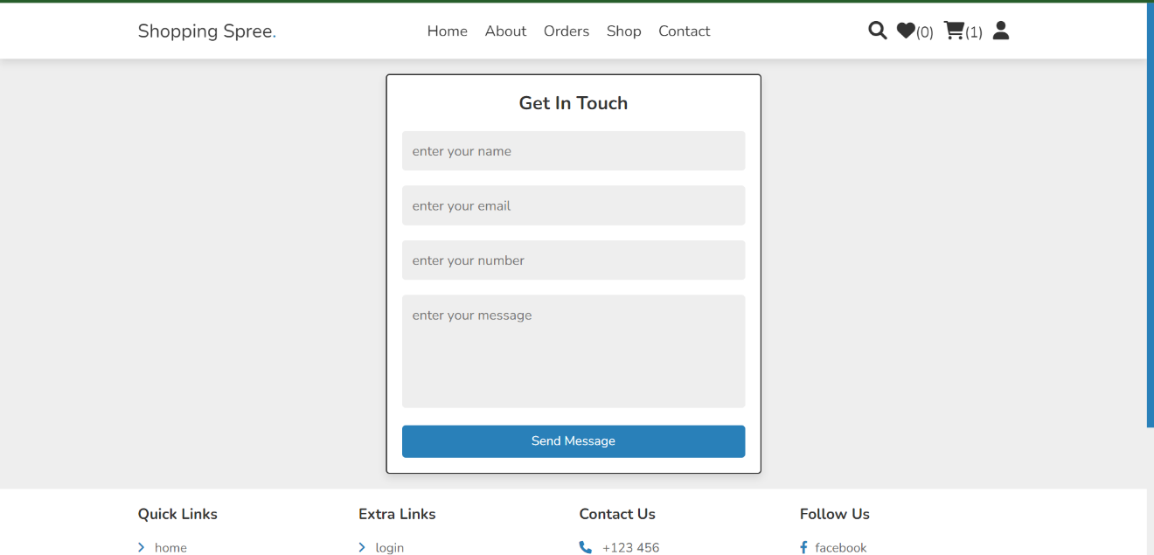

#### 5.8 Edit profile

#### 5.9Log out

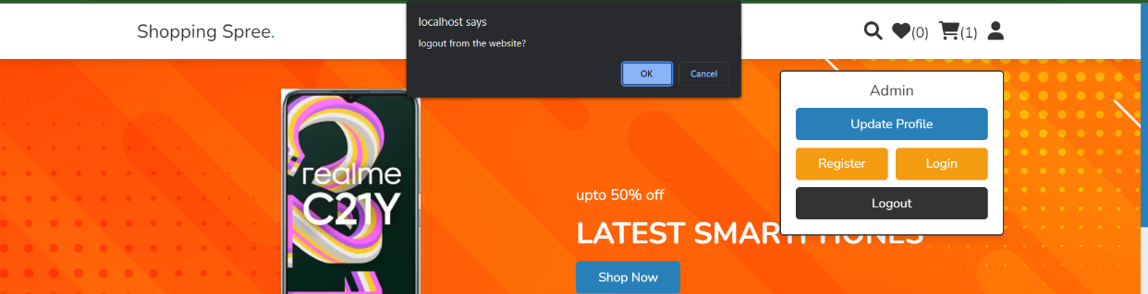

### 6 Security System

This is a retail page where multiple customers and admin can use. Therefore we care deeply about the privacy.

First of all, users can use any password and email they like without duplicating, In addition, the passwords are hashed so that it cannot be depleted from database. The website will warm them when the password is weak. Admin cannot see users information although they can delete them.

Since it is a retail system, credit card and PayPal are options here but customers can pay them when the goods are delivered. In this way, the information about cards or account are not stored and thus cannot be stolen.   
 Another security is for admins. We make the admin pages isolated. Which means customers cannot go nor try to log in as admins as all of the admin frames are built separately.

In the last, when checking orders, customers can only view their orders for other people privacy.

# Section D: System Testing & Implementation

## Test plan, Test data, Test result

Since the interfaces are already described above and will further be explained in User Manual, the testing will be shown in a table.

|  |  |  |  |
| --- | --- | --- | --- |
| Interface | Expected Data | Validation | Error Message |
| Admin Login | Username | -Empty  -not matching the DB | Incorrect username or password |
|  | Password | -Empty  -not matching the DB | Incorrect username or password |
| Admin Sign up | Username | -Empty | Please fill out this field |
|  | Password | -empty | Please fill out this field |
|  | Confirm password | -empty  -not matched | - Please fill out this field  - confirm password not matched! |
| Update profile | Username | -Empty | Please fill out this field |
|  | Password | -empty  -not match | Please fill out this field  -old password not matched! |
|  | New password | -empty | Please enter the new password |
|  | Confirm password | -empty  -not match | -Confirm password not matched! |
| Add product | Enter product name | -empty | Please fill out this field |
|  | Product price | -empty | Please fill out this field  -only allows whole numbers |
|  | Image 01,02,03 | -empty | -please select a file |
|  | Product details | -empty | - Please fill out this field |
| Update product | Update name | -empty | - Please fill out this field |
|  | Update price | -empty | - Please fill out this field |
|  | Update details | -empty | - Please fill out this field |
|  |  |  |  |
| For Users |  |  |  |
| Login | Email | -empty  -wrong format  -not matching the DB | - Please fill out this field  - Please include an '@' in the email address. 'thant' is missing an '@'.  - incorrect username or password! |
|  | Password | -empty | -Please fill out this field |
|  |  | -not matching the DB | -incorrect username or password! |
| Register | Username | -empty | -Please fill out this field |
|  | Email | -empty | -Please fill out this field |
|  |  | -wrong format | - Please include an '@' in the email address. 'thant' is missing an '@'. |
|  |  | -used email | -email already exists! |
|  | password and confirm password | -empty | Please fill out this field |
|  |  | -not match | Confirm password not matched! |
| Shopping |  |  |  |
| Add to Wishlist | New product | -already in cart | -already added to cart! |
| Check out | Personal information | -empty | -Please fill out this field |
|  | Email | -empty  -wrong format | -Please fill out this field  - Please include an '@' in the email address. 'thant' is missing an '@'. |
|  | Number , pin code | -not numbers | - cant type |
| Update profile | Username | -Empty | Please fill out this field(Updating user field is not recommended) |
|  | Password | -empty  -not match | Please fill out this field  -old password not matched! |
|  | New password | -empty | Please enter the new password |
|  | Confirm password | -empty  -not match | -Confirm password not matched! |
| Message | Name | -empty | Please fill out this field |
|  | Email | -empty  -wrong format | Please fill out this filed  - Please include an '@' in the email address. 'thant' is missing an '@'. |
|  | Number | -empty | Please fill out this field |

**Outputs for success**

|  |  |
| --- | --- |
| Interface | Output |
| Admin |  |
| Login | Proceed to home page |
| Register | New admin registered successfully! |
| Orders (update payment status) | Payment status updated! |
| Orders(delete) | Local host confirmation. Then the order will be deleted. |
| Add product | New product added! |
| Update product | Product updated successfully! |
| Delete product | Localhost confirmation .Then the product will be deleted. |
| Update profile | Password updated successfully |
| Delete profile | Localhost confirmation .Then the account will be deleted. |
|  |  |
| Delete User | Localhost confirmation .Then the user will be deleted. (Related info such as messages and orders will be deleted too.) |
| Delete Message | Localhost confirmation .Then the message will be deleted. |
| Logout | Localhost confirmation. Then proceed to login page. |
|  |  |

## System Implementation

### 2.1 Implementation Plan

#### 2.1.1 Requirement Analysis for Electronic Retail Website

1. **Stakeholders**

The following stakeholders will be using the electronic retail website:

1. **Customers:** Customers will use the website to browse and purchase products. They will need to be able to easily find the products they are looking for, add them to their cart, and checkout.
2. **Business owners:** The business owners will use the website to manage inventory, process orders, and track sales. They will need to be able to easily add and remove products from the website, manage product prices and discounts, and view sales reports.
3. **Employees:** Employees will use the website to process orders, manage inventory, and provide customer support. They will need to be able to easily view customer orders, manage product inventory, and communicate with customers via email or chat.

**2.Requirements**

**User-friendly navigation:** The website should be easy to navigate for both customers and employees. Customers should be able to easily find the products they are looking for, add them to their cart, and checkout. Employees should be able to easily access the information and tools they need to do their jobs.

**Secure payments and orders:** The website must use a secure payment processor to protect customer data. It should also have a robust order processing system to ensure that orders are processed and fulfilled accurately and efficiently.

**Scalability:** The website must be able to handle a large volume of traffic. It should be able to scale up or down as needed to accommodate changes in demand.

**Integration with existing systems:** The website should be able to integrate with the company's existing inventory and order management systems. This will allow the company to manage inventory and process orders more efficiently.

*2.2 User Manual*

**Admin**

**2.2.1 Login**

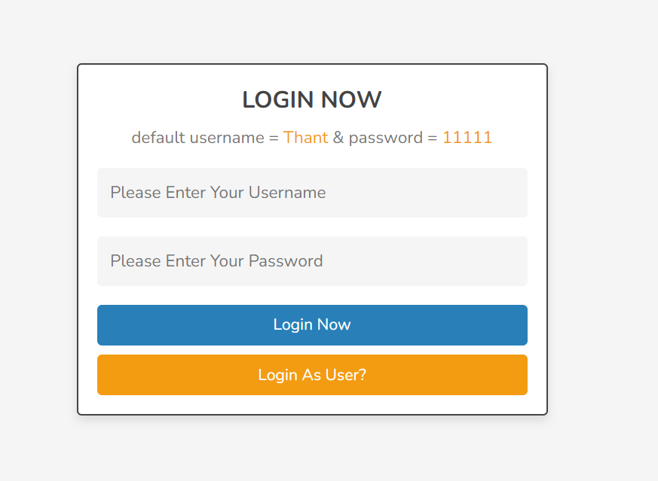

Admin can type the username and password. Then press the LOGIN NOW, a blue button, to login. Admin can login as user too by clicking LOGIN AS USER?, an orange button. The default names are for test run only.

**2.2.2 Home Page**

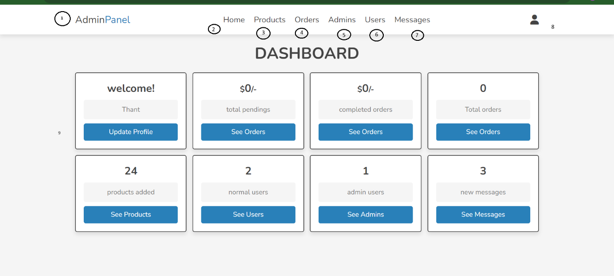

As you can see I marked small notations on Navigation bar.

* 1. Admi Panel : It will lead to homepage which is this page.
  2. Home : It is the same as above.
  3. Products : Clicking on it will lead to Products page.
  4. Orders : Clicking on it will lead to Orders page.
  5. Admins : Clicking on it will lead to Admin page.
  6. Users : Clicking on it will lead to Users page.
  7. Messages : Clicking on it will lead to Message page.

User may also proceed to pages other way around too. Admins can update their profile by clicking UPDATE PROFILE. They can see different orders(pending,completed,total) by clicking respective SEE ORDERS buttons.

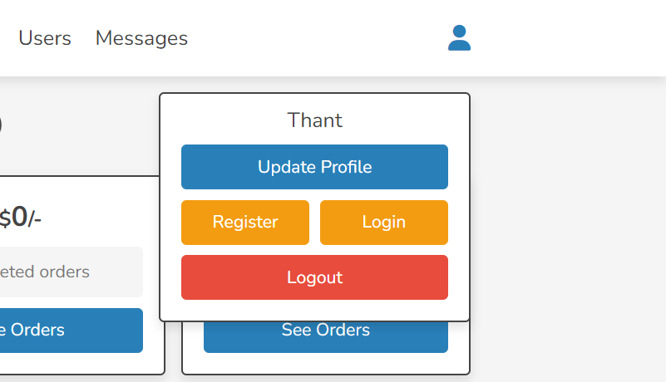The small people icon in home page for users to edit their accounts. UPDATE PROFILE button is to edit name and password. However, it is not recommended to change your name as an admin for consistency. REGISTER button is to add an another admin to the system. The first admin will be added by developer team. LOGIN and LOGOUT buttons are used to get in and out of the system.

**2.2.3 Update Profile**

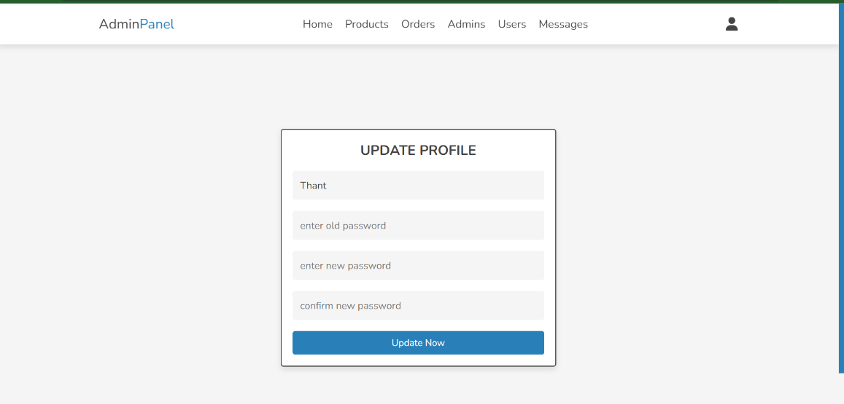

In this interface, after filling the form and information correctly, UPDATE NOW button will change your information in the database.

**2.2.4 Register**

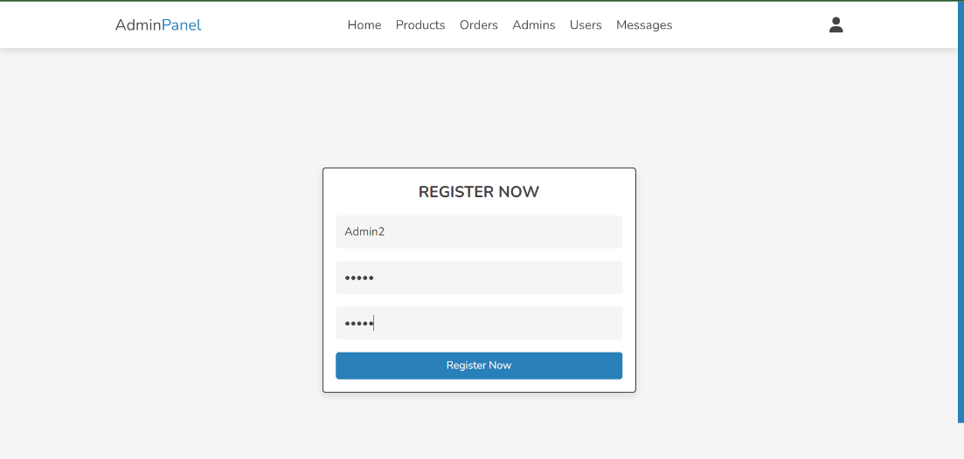

An existing admin can add another admin by filling the information and clicking REGISTER NOW button.

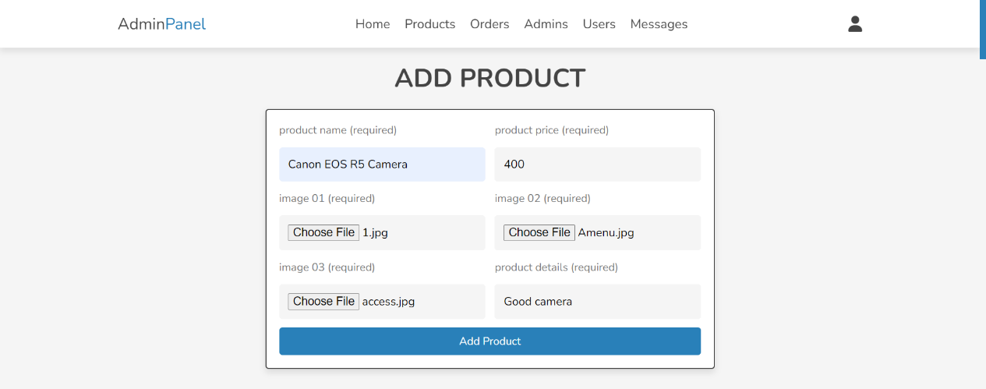**2.2.5 Products**

**Add Products**

In this interface, admin can add products by filling the information.

**Product name:** Admin can add the name of product, the system will use the words in this for searching.

**Product price:** Admin can add the price to it. It only allows whole numbers for easier system in calculating orders for customers.

**Image 01:** This image will be used as a main photo. Admin can choose jpeg and web types. They can also try others file type, if the browser supports it.

**Image 01** **Image 02:** These images will be used when the user view the product detail.

**Product details:** Admin can write the details of the product they are selling.

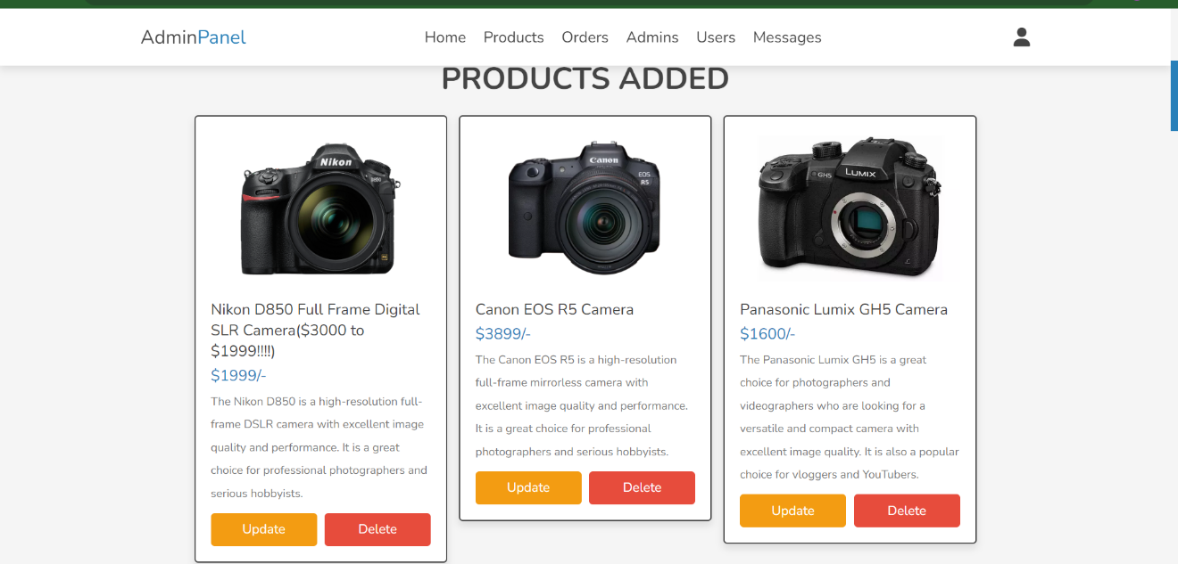 Then admin can finalize all the details about the product by clicking ADD PRODUCT button.

**2.2.6 View and Edit product**

Admins can view added items they added below. They can update and delete the products by   
UPDATE and DELETE buttons.

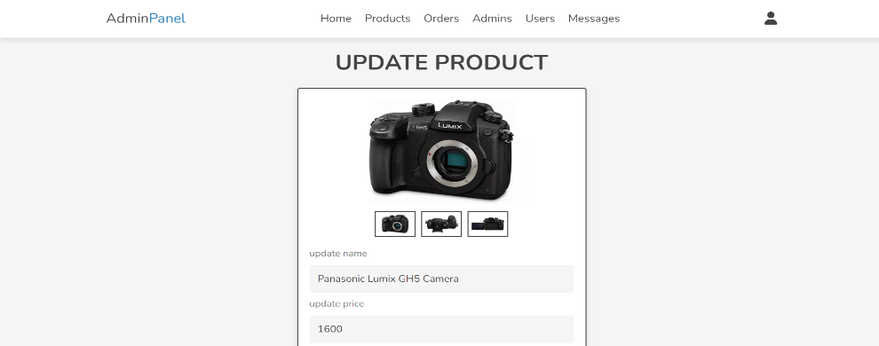**2.2.7 Update Product**

This is the update page, admin can change the details. The process is similar to add product process.

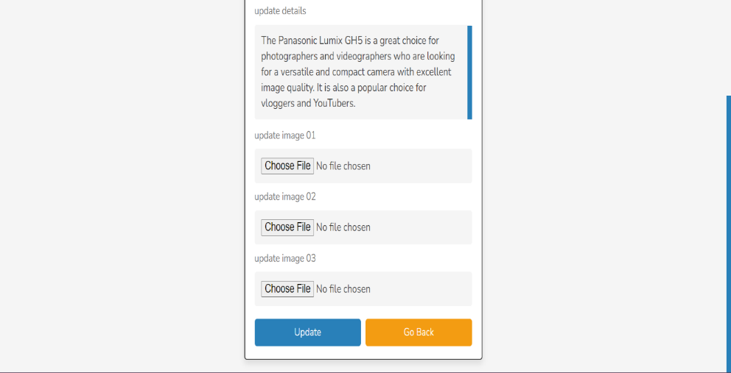Then admin can update the details by hitting UPDATE button.

They can go back to product page by clicking GO BACK button.

**2.2.8 Delete Product**

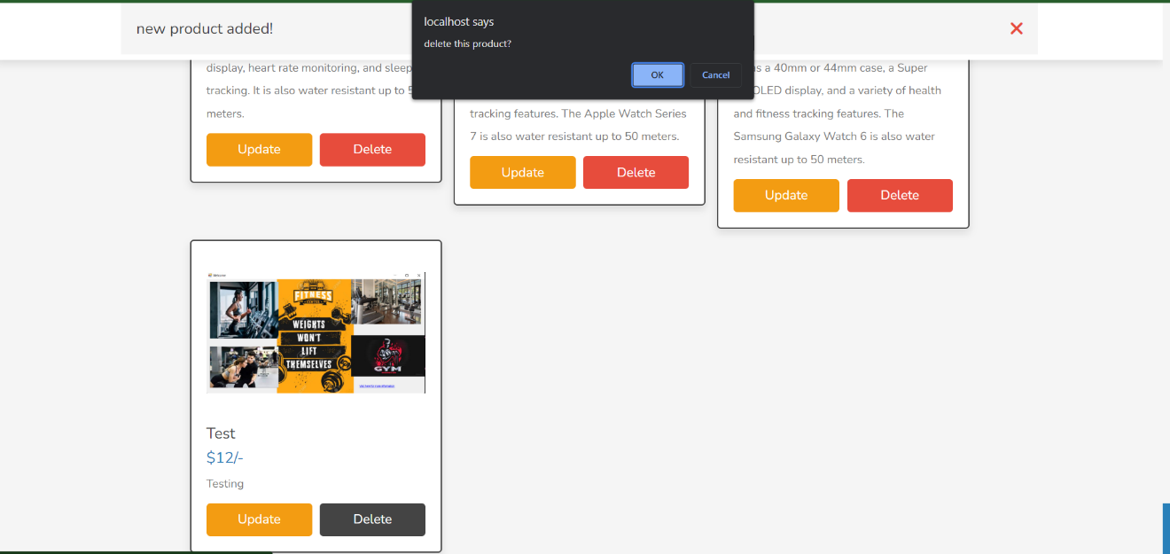Admin will be ask for confirmations, if they press OK they will be deleted. If CANCEL they will go back to product page.



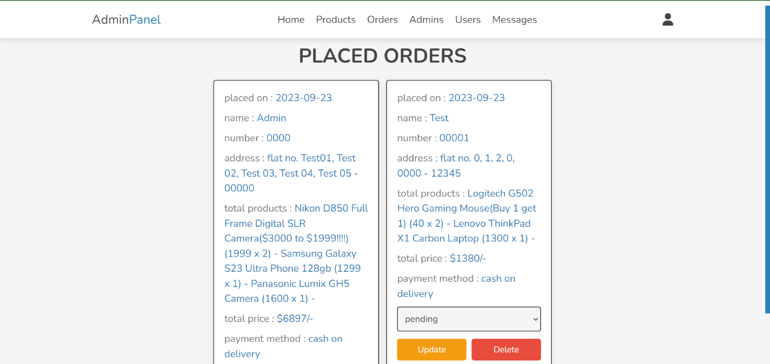2.2.9 O**rders**

In this page, admin can view orders. They can also change the status of order by clicking the PENDING to COMPLETE or vice versa. They can also update and delete them by clicking UPDATE and DELETE buttons.

For the orders that are already paid, the admin can change the status to completed, otherwise it can be said to pending as default.

DELETE button will ask the admin for confirmation and if confirmed, the order will be deleted.

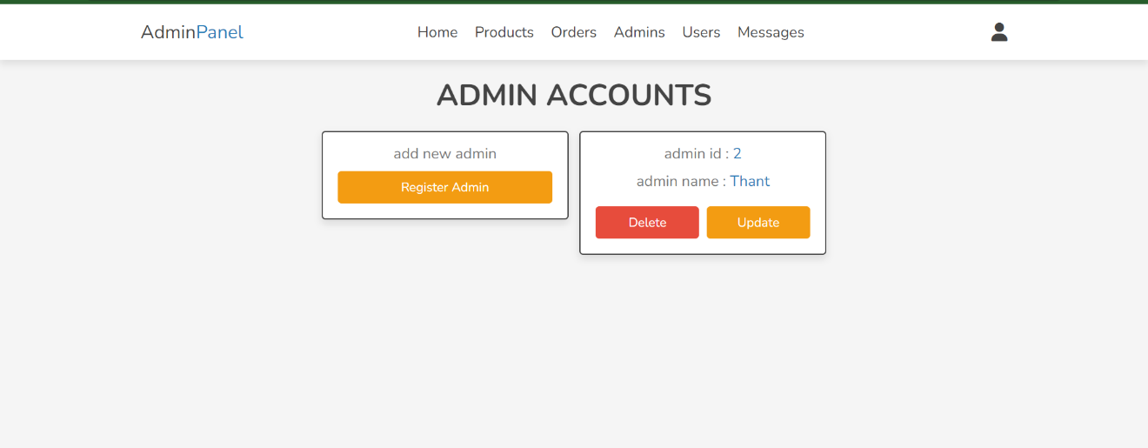**2.2.10 Admins**

In this page, admins can delete, register or update their accounts by clicking REGISTER ADMIN, DELETE and UPDATE buttons. Those pages are explained above.

**2.2.11 Messages**

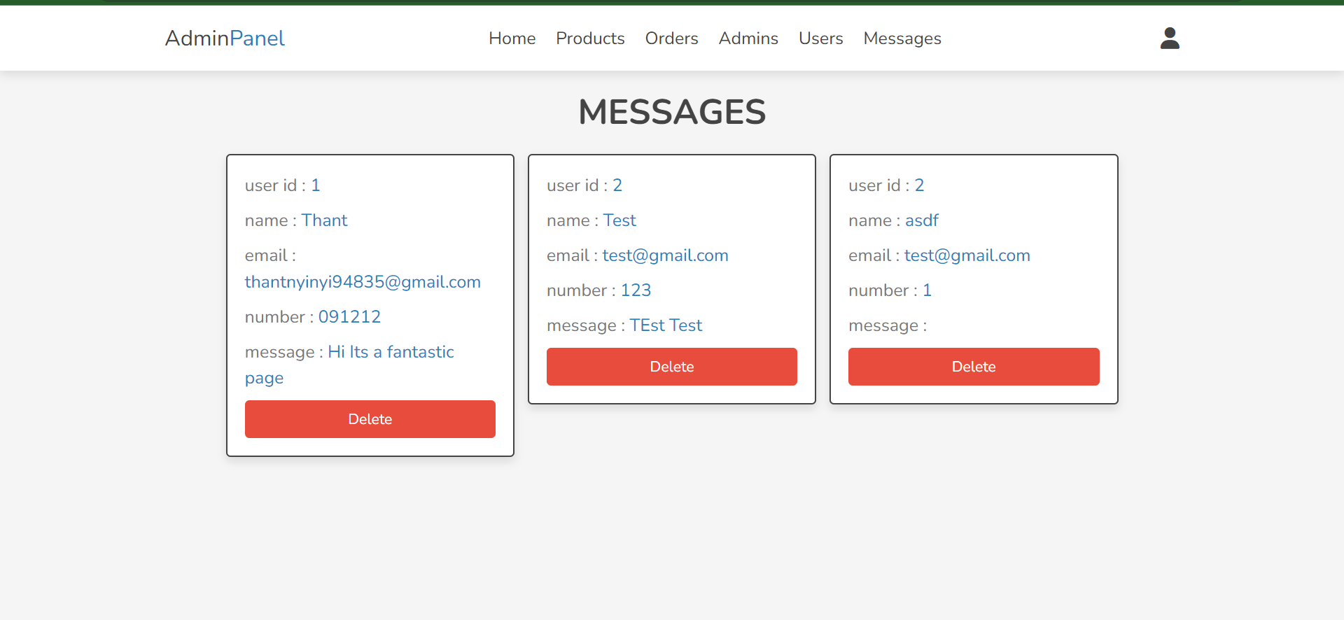

Admins can view the messages from customer, DELETE button will erase the message.

**2.2.12 View Users**

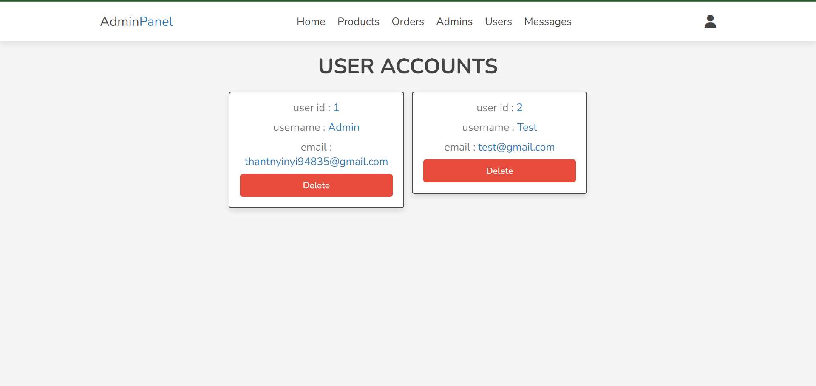

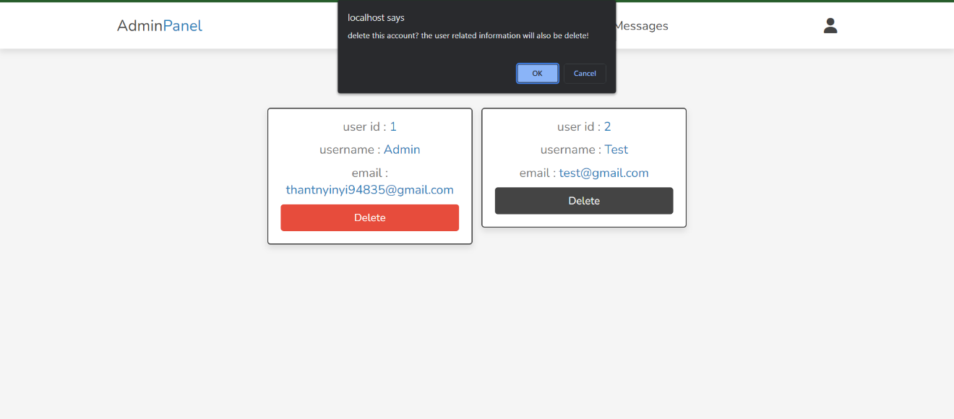 Users can be deleted by admins by clicking DELETE button on the page.

However, the data such as orders and message that are related to the user will also be deleted.

**Users**

**2.2.1 Login**

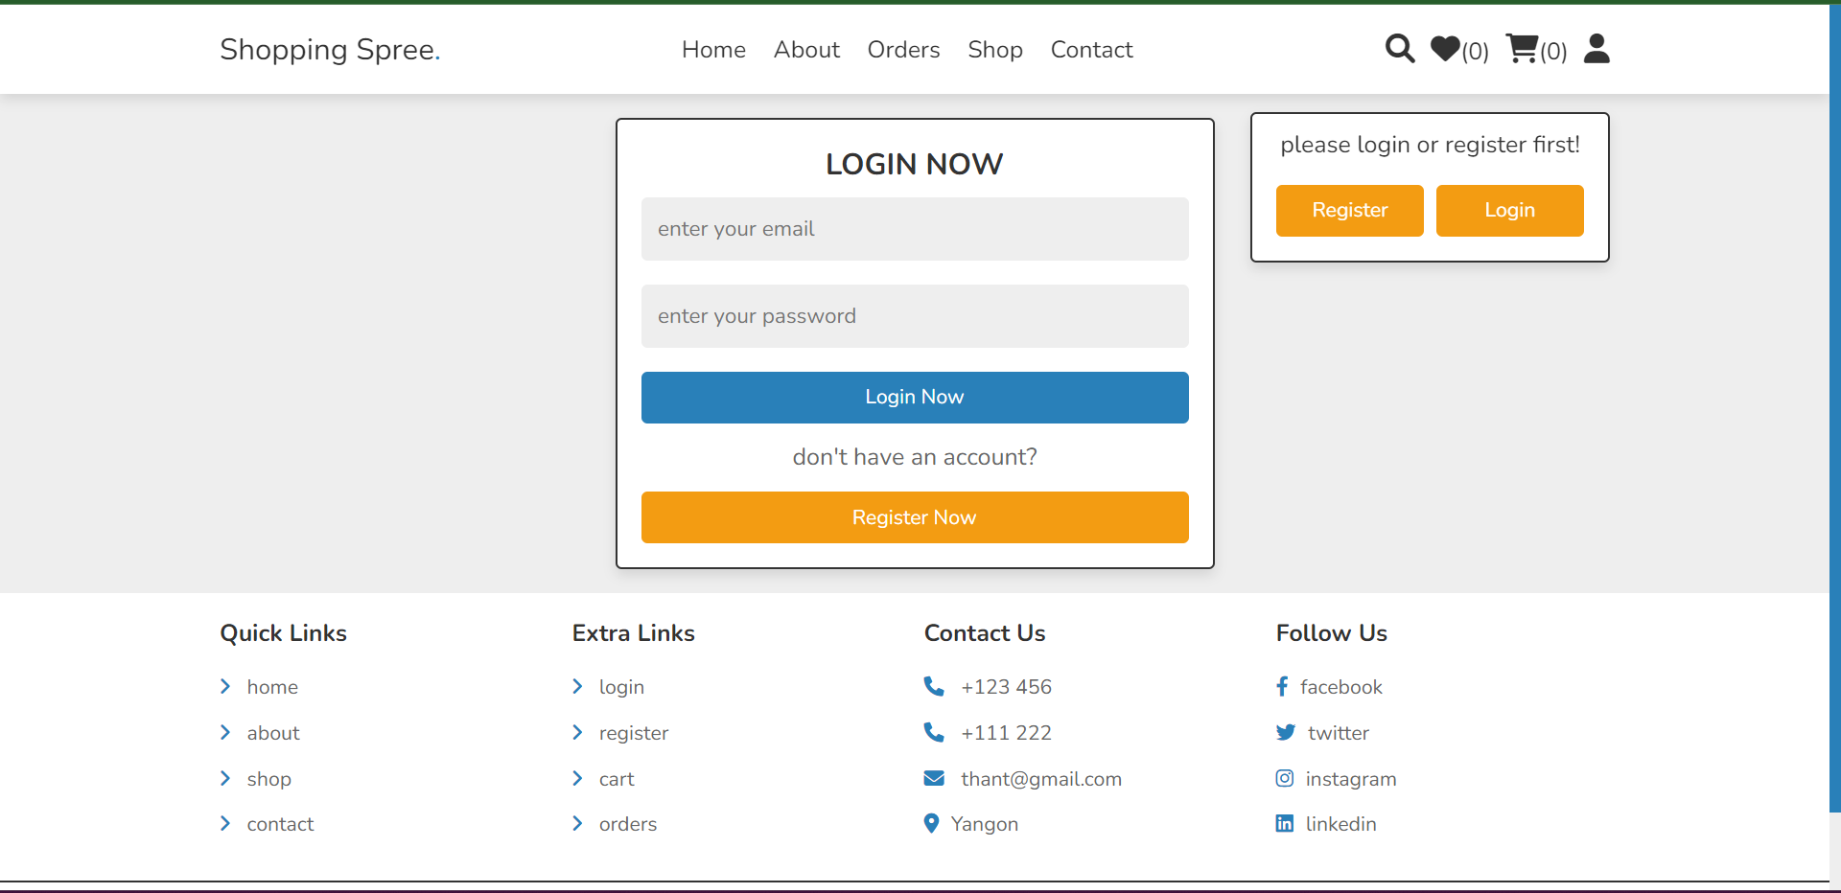

|  |  |
| --- | --- |
| Feature | Function |
| Shopping Spree logo text | Bring to homepage |
| Home | Bring to homepage |
| About | Bring to about us page |
| Orders | If the user is logged in, it will bring to orders page. Otherwise, the system will ask to log in. |
| Shop | Bring to products page |
| Contact | Sending messages |
| Search icon | Searching Products by name |
| Heart icon | Adding items to Wishlist |
| Cart icon | Adding items to cart to checkout |
| Register | To register if the customers doesn’t have an account |
| Login | Bring to Login page |
| Login Now | After typing email and password, the customer can click on the button to login. If the data are matched it will lead to homepage. |
| Register Now | Lead to register page |
| Footer | |
| Quick Links | Lead the customers through our webpage. For instance, clicking on home will bring to home page. |
| Extra Links | User interfaces like Login, register or add to card can be accessed via here too. |
| Contact Us | Customers can view our company details and contact list in the page. For instance, clicking on [thant@gmail.com](mailto:thant@gmail.com) will lead to send email to the company. |
| Follow Us | Customers can follow and keep up to date with us on the social media too. |

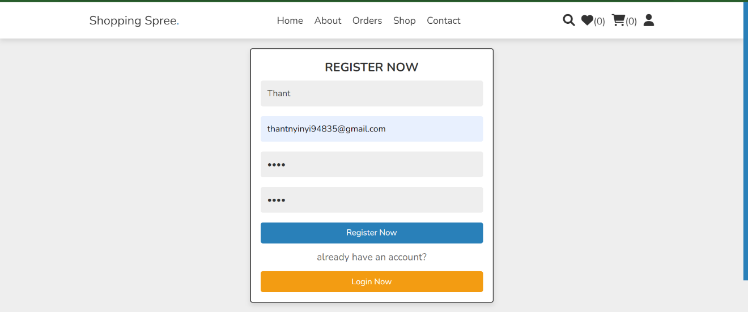**2.2.2 Register**

To register an account at our website, users need to fill out Username,email,password and confirm password. If all the validations are correct, system message will be shown and they can login to the page when “Register Now” button is clicked.

**2.2.3 Home page break down**

**2.2.3.1 Discount banners**

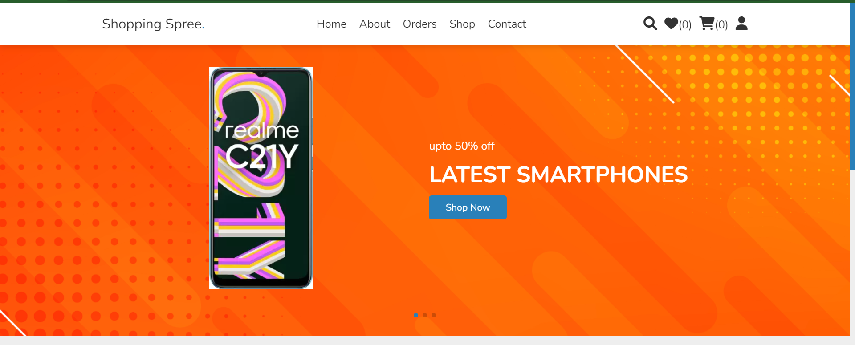

In this part, customers can click on the “Shop Now” and go directly to the discounted product.

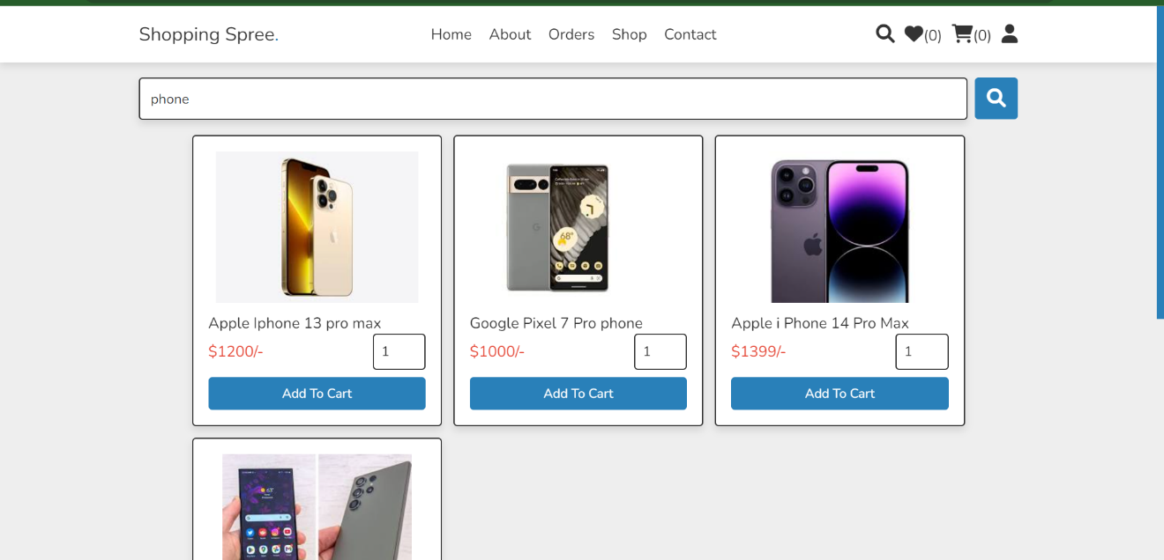**2.2.3.2 Search**

In this features, customers can search their prefer product by typing the names in the Search Bar and clicking on Search Icon.

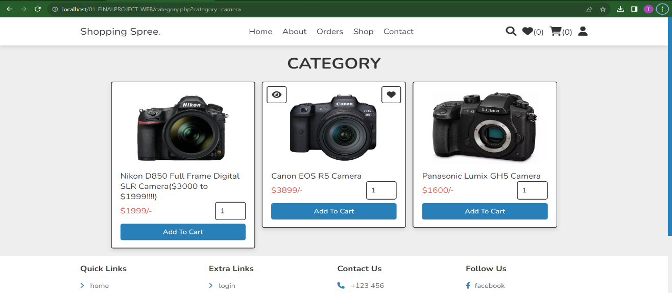**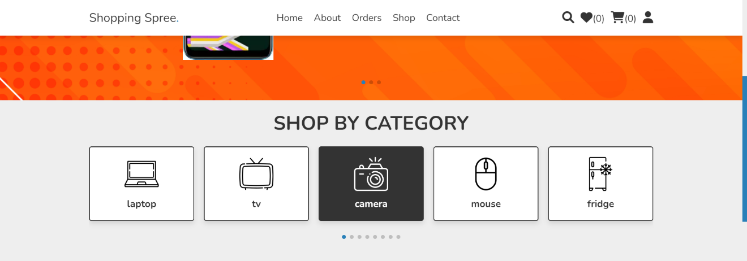2.2.3.3 Category search**

For customers who doesn’t have certain name to search, they can also choose from 8 different categories available at our website. By clicking on the specific category photo, customers can view the products.

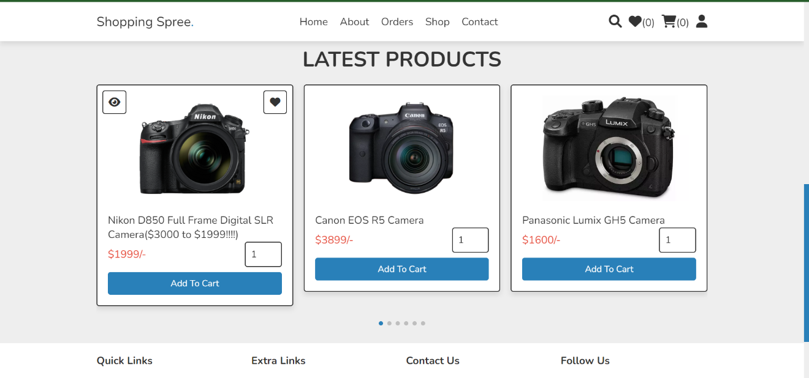 **2.2.3.4 View Products**

The customers can also view all the products in this page. They can add to Wishlist, view details and add to cart.

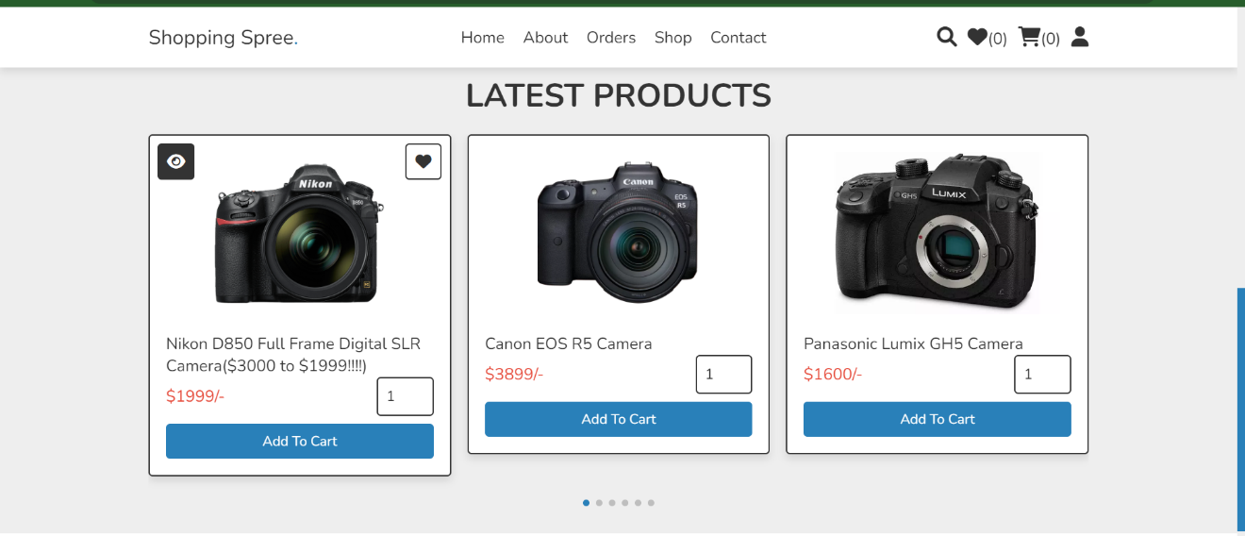**2.2.3.5 View Details**

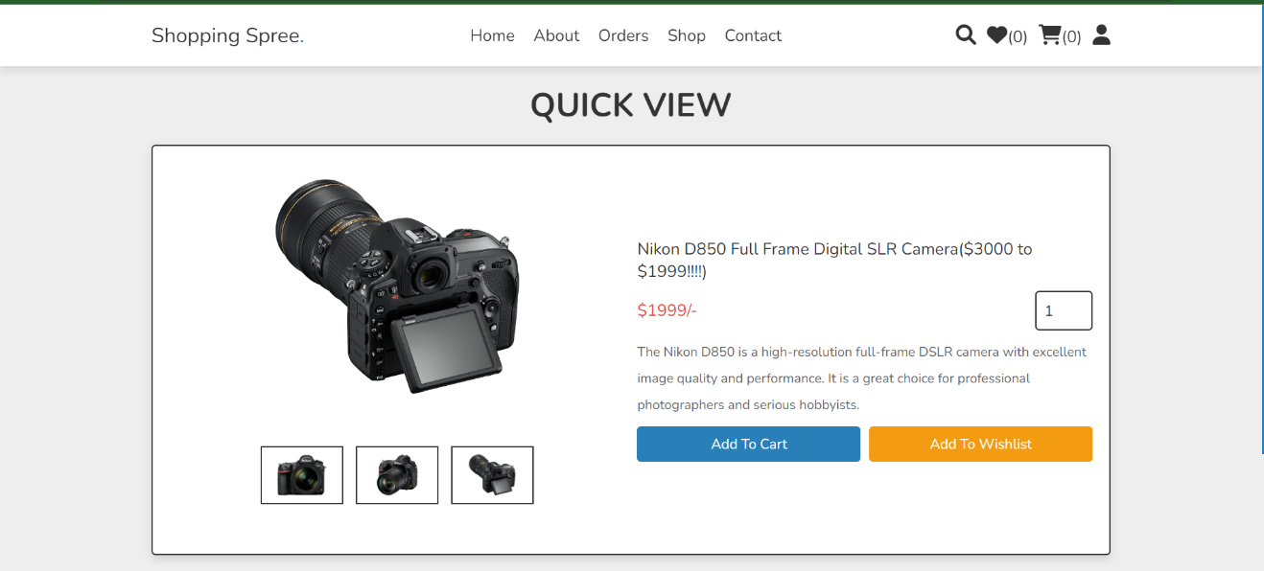By clicking on the eye icon, customers can quick view details of the product.

In this page, users can view 3 different photos of the product for more information by clicking the photos. Users can also add products to cart and Wishlist by “Add to Cart” or “Add To Wishlist” buttons.

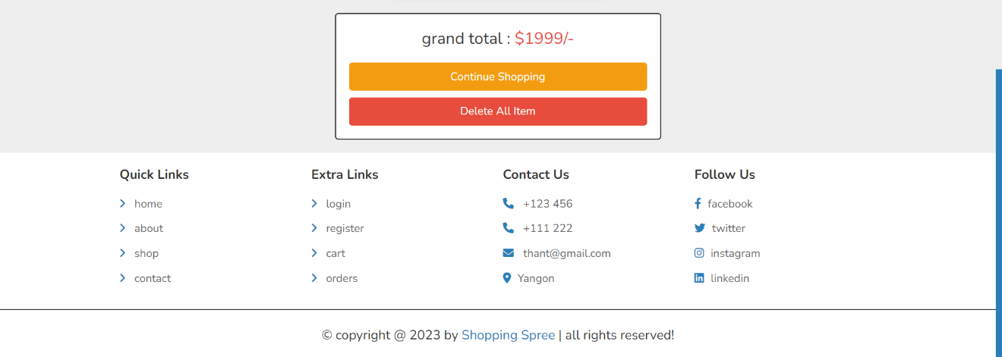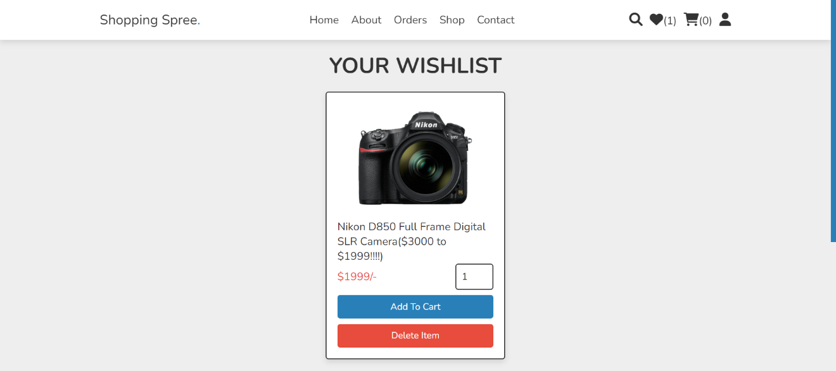**2.2.3.6 Add to Wishlist**

By clicking on the heart icon, customers can add the products that caught their eye to Wishlist to buy for later. “Continue Shopping” button will lead to shopping page. “Delete All Items” button will delete the items from Wishlist. “Add to Cart” button will move the item from Wishlist to cart, which means it will no longer be in the Wishlist. In addition, the products already in the cart cannot be added to Wishlist so that customers will know the products more.

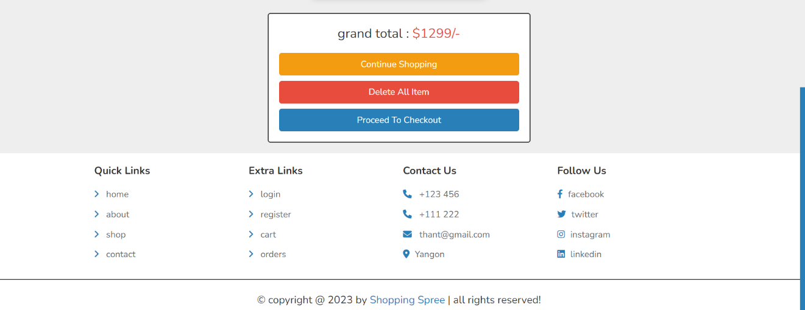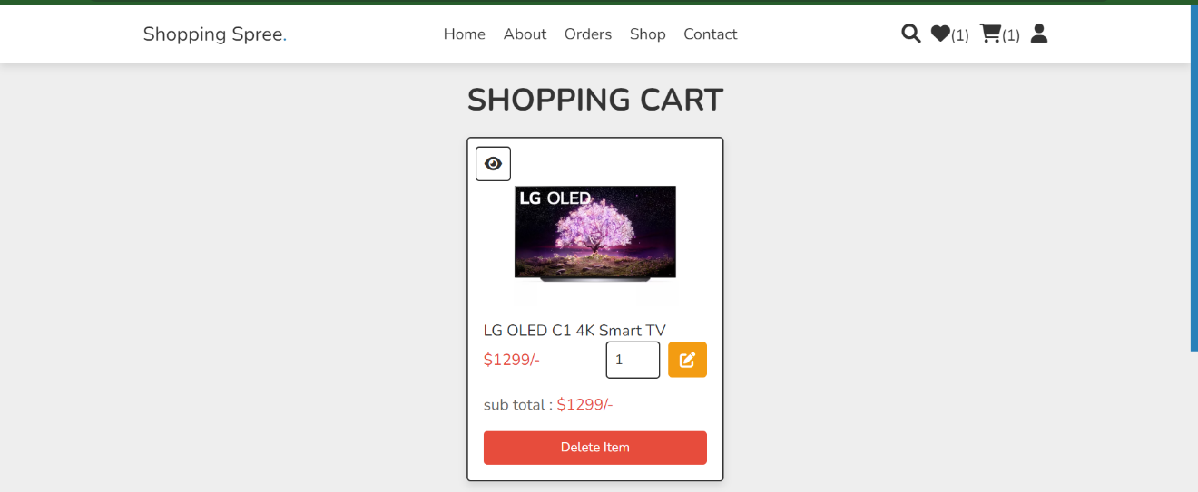**2.2.3.7 Add to Cart**

Customers can add the products to the cart by clicking “Add to Cart” button. In this interface, they can also add quantity by increasing the number box just below the product name.   
After changing the number, click on yellow Pen icon to update the grand total. “Delete item” will delete that item. “Proceed to Checkout” button will lead to final ordering page. Customers can see how many products they have added to the Wishlist and cart by checking the numbers on those icons on the nav bar.

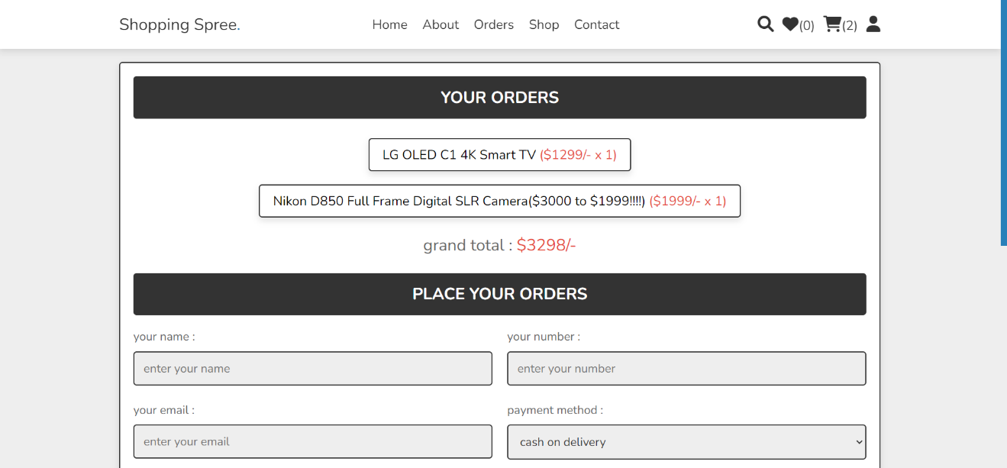**2.2.3.8 Proceed to Checkout**

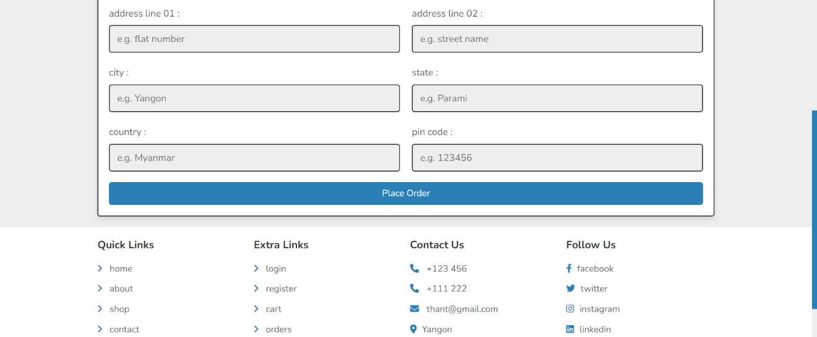 In this page, the system will show the customers a receipt about their orders and grand total. Customers will have to fill out the form for shipping and delivery. If the validations are correct the order will proceed when “Place Order” button is clicked.

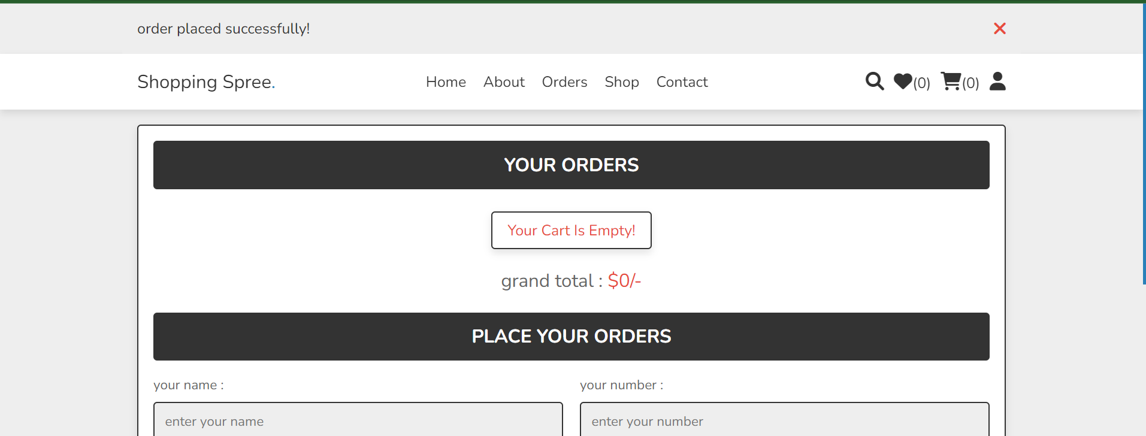

After the order is completed, the products from the cart will be removed.

**2.2.3.9 View Orders**

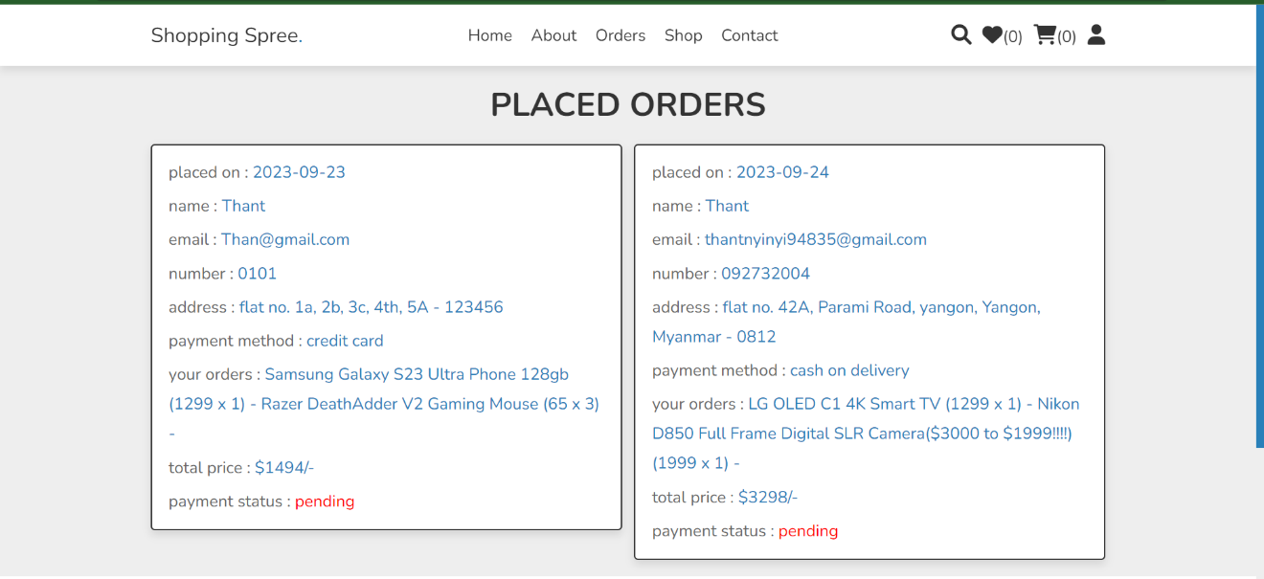Customers can watch their orders in orders page.

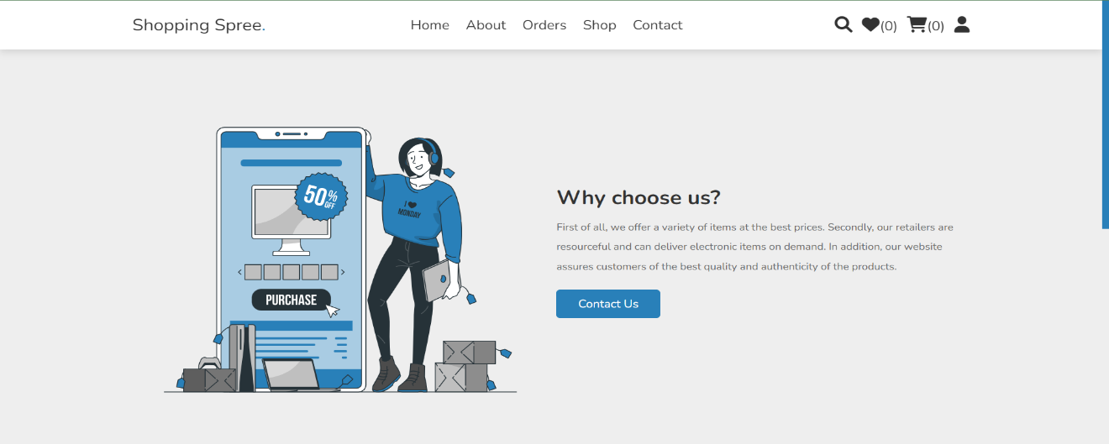**12.2.3.10 Contact us**

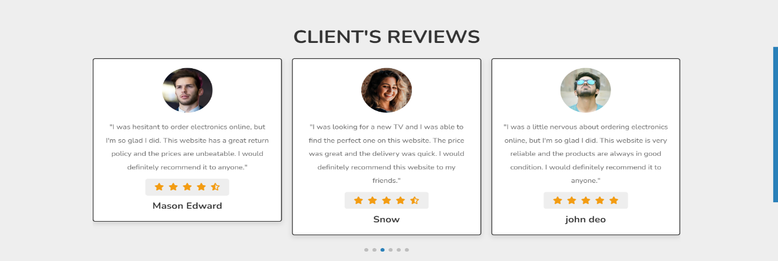Customers can view about our page here. They can also check reviews of the month so that they can trust the page more. “Contact Us” button will lead to messaging page.

**2.2.3.11 Message Us**

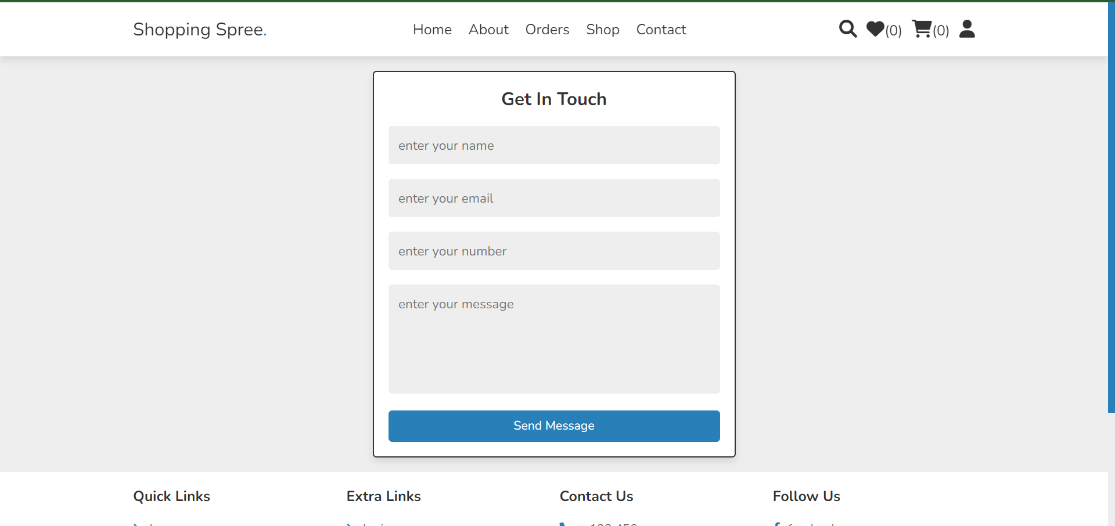

Customers can send us messages by enter the information and clicking “Send Message”.

# Section E : Critical Appraisal

## System Limitation

**Password :** Since there is no forgot password function, if the customers forgot password, the account can be really hard to recover.

**Inventory:** The company do not store goods in-stock. We only order them from other sources when the order is confirmed by customers. Therefore, if there were a lots of orders in a short period, there could be problems in getting the items.

**Delivery:** The system does not involve replying for arrival of goods. The admin have to manually send emails to the account about cargo shipping and arrival of time.

## Recommended changes

There are few changes that would make the website and company better.

**Forgot Password:** Adding this function will help recovering their accounts when they forgot password by sending reset code via their emails.

**Order Cancel:** As it is mentioned, since we only order items when users confirm the order, there is no cancel order function to avoid the loss of company. However, in the future when the company grow, it would be better to add the cancel features.

**Inventory:** In addition, it would also be better if we have limitations on orders like how many order of specific items per day.

**Shipping:** Moreover, it would be a good idea to add the shipping system and arrival time reply in the system.

**Review:** Current system is adding reviews from message to the page manually by developer team every month to avoid spam reviews. However, after the page have gain some reputation, it would be great to add the customers reviews directly to the page.

## Critical Reflection of the Project Experience

The process of developing an electronic retail website was a complex one that produced both successes and revelations. In keeping with the original objectives, the website successfully streamlined the product cataloguing, order processing, and customer management processes. The user experience was improved by novel features such as a categorized recommendation system and a simplified checkout process. However, difficulties with integrating with existing payment systems emerged, which could cause unanticipated delays.

Communication turned out to be crucial, and open dialogue within the team encouraged cooperative problem-solving. Customer feedback was actively sought after, and user-friendly interfaces received favorable responses. Technical difficulties surfaced, especially with regards to security and performance, which led to a change in the underlying technology stack.

This project served as a reminder of the importance of staying within the project scope; scope creep led to time and resource overruns. These incidents demonstrated the necessity of flexible project planning and risk management.

This project helped me develop my project management skills and my technical knowledge. Future recommendations include ongoing customer interaction and predicting scaling demands, taking into account the impact on effective retail operations and customer satisfaction.

The project proved that customer-centricity, strong teamwork, and technical proficiency must all be combined for e-commerce website development to be successful.

## References

<https://www.macrumors.com/>

<https://www.engadget.com/>

<https://www.zdnet.com/>

<https://www.apple.com/shop/buy-iphone/iphone-13/6.1-inch-display-128gb-blue-unlocked>

<https://www.ajmadison.com/cgi-bin/ajmadison/WM3900HBA.html>

<https://www.subzero-wolf.com/sub-zero/full-size-refrigeration/builtin-refrigerators/48-inch-built-in-french-door-refrigerator-freezer>

<https://news.samsung.com/us/family-hub-3-0-refrigerator-ces2018/>

<https://www.amazon.com/ref=nav_logo>

<https://laptopmedia.com/>

Critical Reflection of a Project Experience by the Project Management Institute (PMI): <https://www.pmi.org/learning/library/embedding-project-knowledge-through-reflective-practice-6369>